**JD DOG CARE**

**Name:** Stergious Aji

**Candidate Number:** 4211

**Centre Number:** 71887



**Lumen Christ College**

Software System Development

# Analysis

## **Background**

JD Dog Care is a successful business based at a farm location just outside of Newtown. The

farm and the dog care business are owned by John and his wife Diane and has been in business for nearly seven years. The business has extensively grown and diversified over that time and with that came an overwhelming number of customers and demand. Diane successfully achieved an accredited professional dog grooming Diploma as well as a Certificate in Animal Care and Welfare. It is evident that Diane is well qualified in the care for animals, but her knowledge of business procedures is limited.

**Dog Grooming**

JD Dog Care has offered a basic dog grooming service since when the opened. This involved booking dogs for scheduled appointments from Monday to Friday, 9am to 5pm. Diane records appointments in a diary and basic details are noted beside each entry, like the client’s name, address and telephone number and their dog’s name and the service option selected for the appointment. Diane insists on an additional 15 minutes for first time clients to become familiar with the dog and to discuss treatments and additional information about the dog. This adds an extra £5 fee to the final bill.

The service options include:

* Option 1 – Wash, shampoo and brush
* Option 2 – Wash, shampoo, brush and trim
* Option 3 – Wash, shampoo, brush and full cut

(Nails, teeth and ears can be incorporated with any of the service options for an extra fee)

One-off clients pay after the grooming service is completed while regular clients can choose to pay monthly preferably by standing order or by cash or card (Cheques are not accepted). Receipts are given to all clients after the service option has been paid for and monthly invoices are prepared for those who pay in a monthly contract. Clients who book three appointments in advance are given a 5% discount. John and Diane have recently introduced a range of additional treatments including allergy therapies. It was decided that these treatments require an initial assessment appointment and at least three more follow-ups over a period of six weeks. Clients must pay in advance for the assessment appointments in order to plan and set up the follow-up appointments. Invoices are sent before the completion of the three follow-up appointments.

The work at JD Dog Care is divided as follows: John and Diane take charge of the day to day running of the business like the maintenance and administration of the centre. They have recruited two full-time members of staff, Elaine and Richard, and one part-time staff member, Jane, who has committed to five half-day sessions per week. The staff members work in shifts and are responsible for caring for and grooming a dog for the allocated booking. At present, there are three grooming rooms at the centre meaning a maximum of three dogs can be booked at the one time during busy times.

## **Business Problems**

Evidently, JD Dog Care runs in a very traditional manner with all bookings, invoices and client and dog records being physically written on paper and stored in filing cabinets at the centre. This can be very taxing and time-consuming and is a huge risk as for one, if access to these important documents is not properly restricted, a security breach is more likely to occur which can have a disastrous impact on the business. Secondly, during busy times, not everything will be recorded which causes issues with appointments. The time allocated for each grooming option varies. This can be a problem and clients are often kept waiting before or after their appointments, as in many cases the appointments do not start or finish at the scheduled time.

Another huge problem is keeping track of invoices if they are paid or if they are not. Copies of these invoices are retained in the salon and should be marked ‘Paid’ after payment is received. This does not always happen, and clients have complained that they have been sent further invoices for services that have already been paid. Clients are normally given two weeks to pay before a reminder is sent out. If invoices remain unpaid, clients are issued a ‘Reminder’ and a duplicate invoice within three weeks of the original invoice. Further appointments should not be made for clients who have not paid until the bill is settled. It is extremely difficult to manage these accounts and unfortunately reminders’ have been sent out incorrectly and further appointments have also been made.

All documents need to be very well organised or else it will lead to confusion and inconsistent data. At times the salon could be so busy that there is barely time to answer the phone. Clients sometimes leave a message on the answer machine to book an appointment. They often assume that Diane recognises the name of the dog and the owner and do not provide any further details. Of course, this is not the case as many dogs have the same name and not all owner details are recalled. Appointments may not be recorded as a result. Diane is always annoyed at having to repeatedly write the same details for her regular clients. Booking arrangements are clearly problematic, and John and Diane realise that they are not using the available resources effectively.

## **Proposed Solution**

In response to these issues, John and Diane have decided to redesign and improve the administration system at JD Dog Care by developing an IT system in hopes to automate parts of the process that are monotonous and time-consuming. This will increase efficiency of the staff members as their focus will be less on the administrative processes and more on the care of the animals in the centre, improving the quality of business. Security will be less of an issue with the software system as usernames and passwords can be implemented to restrict access to only qualified members of staff. The new system aims to make invoices for each of the client easy to keep track of and prevent further appointments from clients who have invoices yet to be paid. Reminders can automatically be sent through e-mail or post after the two-week and three-week periods. The system will ensure that all data is entered and inconsistencies in data storage will be minimised or even eliminated as data only must be entered once making booking appointments faster and more reliable.

## **Methodologies Overview**

### **Standard Waterfall:**

The waterfall model follows a simple, sequential development process where each phase depends on the deliverables of the previous one. This traditional approach requires detailed and precise up-front planning and documentation before any work is started. This means that all the user’s requirements must be analysed and validated until there is a straightforward, clear path and end-goal to the project. The name ‘waterfall’ stems from how the development process mainly flows in one direction, downwards, like a waterfall, through the phases, conception, to analysis, design, implementation, testing and finally maintenance. Each stage of development proceeds in a strict order.

#### Advantages:

Due to the waterfall model involving a lot of documentation defining each phase in the project, new developers can be quickly brought up to speed at any stage during the development process. The strict, rigid procedures also enforce discipline among the team so that their sole focus is on the current task. This makes large teams easier to manage for project managers as each stage has a specific deliverables and milestones that need to be kept on top of. In addition, during the analysis, the costs can be estimated with a fairly high degree of accuracy and so the budget could be changed or planned for at an earlier stage.

#### Disadvantages:

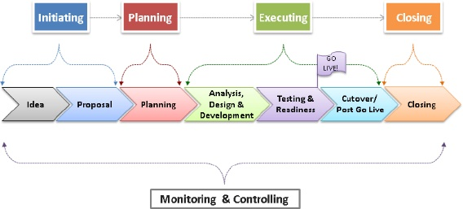Although the waterfall model is very robust, it has several disadvantages, for instance, it cannot accommodate changing environments and requirements. This method is only suitable for projects where the requirements are fixed and well-known. Another major drawback of the waterfall approach is the limited involvement of the end-user or the customer which increases the risk of customer dissatisfaction of the end product as they cannot give feedback during the design and implementation stages which may lead to redevelopment increasing the cost and time. Another critic is that the project management is very repressing, and this does not help encourage creativity within the team and use their skills in the best way. As the package is only integrated at the end of the lifecycle, often called a ‘big bang’, issues are likely to surface with incompatible code between developers due to miscommunication, resulting in redevelopment increasing time and money.

*Figure 1 – Standard Waterfall Model*

https://www.pmi.org/kasimage/c4262e89-91f6-4b1d-a758-df86a2b484b5/p1_01.jpg

### **Rapid Application Development (RAD):**

Rapid Application Development is a type of incremental and iterative development model which was designed in response to the critiques of the waterfall model. RAD compresses several stages of the waterfall model into an iterative process that prioritises prototyping and a higher level of user involvement and feedback. The development team delivers a fully functional prototype of the product which is then met with an evaluation from the user or customer. The prototype is then refined to the user’s needs and this process repeats until the prototype evolves into the final working product that will satisfy the user/customer. This is known as evolutionary prototyping, however, RAD also uses throw-away prototyping where instead of refining the existing prototype, a new version of the software package is created from the ground up accommodating the new needs of the user.

#### Advantages:

One major advantage to RAD is that there is less up-front planning meaning more time can be spent on developing and testing the software product. Additionally, the user requirements do not need to be well defined in the beginning as prototyping takes care of this. RAD divides the project into several compartments for which separate prototypes can be developed in parallel, speeding up the development process and shortening the life-cycle. Changing environments and requirements can be easily incorporated in the evolving prototypes and so this reduces the risk of not meeting the customer’s requests and therefore leads to a higher customer satisfaction.

#### Disadvantages:

RAD is inapplicable to projects with low budgets as the cost of Computer-Aided Software Engineering (CASE) tools for modelling and automated code generation are very high. Additionally, RAD requires highly skilled developers and designers who have lots of experience and a large skill set in order to swiftly respond to the customer’s changing requests. The RAD model also demands more frequent user involvement throughout the development lifecycle which would require a lot of commitment from the customer to achieve the targeted prototype in the given time frame.

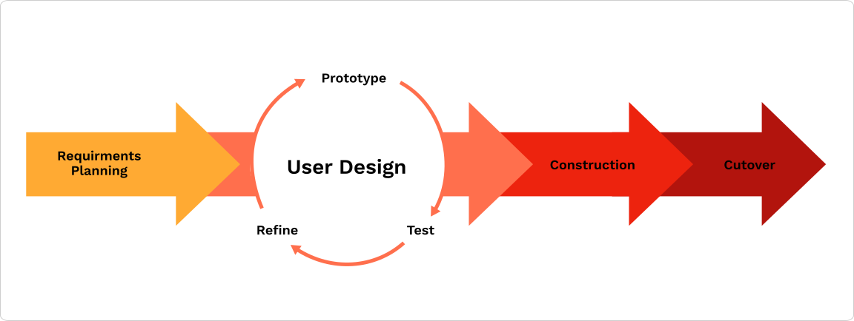

*Figure 2 – RAD Model*

https://roadmunk.com/guides/content/images/2019/07/method-ch1-6a.png

### **SCRUM:**

*Figure 3 – SCRUM Process*

Scrum is a lightweight process framework and a subset of Agile methodologies. Scrum uses iterative and incremental practices with a main goal of increasing productivity and reducing the time taken to complete the project. It is designed for teams of up to nine to twelve developers who break their work into milestones that are completed in time-boxed iterations called sprints. These sprints last no more than two to four weeks and at the end of each sprint, a fully integrated and tested product that is potentially releasable must be released for the customer to review. At the start of each day during a sprint, a Daily Scrum (or a Stand-Up meeting) is held at the same time and same place and is restricted to 15 minutes. During the Daily Scrum, each Team member explains what they completed yesterday, what they plan to complete today and if they have any issues that will stop them from completing their tasks.

https://d30s2hykpf82zu.cloudfront.net/wp-content/uploads/2019/09/Scrum-Method-1024x751.jpg

#### Advantages:

Scrum is very efficient at enabling development teams to complete project deliverables in a rapid fashion and this is one of the main reasons that Scrum is the most popular Agile methodology, according to the 12th annual State of Agile report, 70% of software teams use Scrum or a Scrum hybrid. Scrum is extremely suitable for large projects as it breaks it up into manageable sprints for the development team. The Team in Scrum are self-organised and choose amongst themselves which parts each member will tackle in alignment with their specific skill-set. This improves efficiency and ultimately creates a software package that is better in quality. User feedback is an important aspect of Scrum, being an Agile model, and so this ensures that the final shippable product is in line with the user’s standard and satisfaction.

#### Disadvantages:

For Scrum to work at its best, all individuals must be fully dedicated and cooperative, including the customer and/or user. A consistent high level of communication between all participants in each Daily Scrum and meetings with stakeholders is essential for this framework to work effectively. If this is not the case, the project is bound to fail. In addition, Scrum requires highly experienced software developers and designers to reduce the risk of scope creep, which is when the project’s scope grows uncontrollably at a point after the process has begun. Poor definition of tasks and requirements can also lead to failure as it leads to inaccuracies during the development process.

### **Dynamic Systems Development Method (DSDM):**

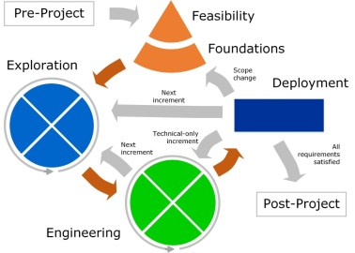Dynamic Systems Development Method is another agile project delivery framework that focuses on the full project lifecycle, using an iterative and incremental approach with continuous user/customer involvement. It makes steps to ensure the feasibility and business sense of a project before it is created. DSDM emphasises on in-budget and on time product delivery with variable functionality to address projects of all sizes. In order to keep to the budget and be on time, DSDM uses MoSCoW prioritisation to leave out unnecessary requirements, reducing the project scope. The MoSCoW mnemonic simply means Must haves, Should haves, Could haves and Won’t haves. DSDM makes a heavy use of prototyping and this ensures that all interested parties have a clear picture of the various aspects of the system.

*Figure 4 – DSDM Model*

https://i0.wp.com/s3.amazonaws.com/production-wordpress-assets/blog/wp-content/uploads/2017/02/21081140/dsdm.jpg?fit=378%2C270&ssl=1

#### Advantages:

In DSDM the basic functionality is delivered quickly with more functionality being delivered at regular time-boxed intervals in the form of the evolving prototype, this means the customer can see evidence of progress being made from very early on in the process. Like all agile methodologies, the constant user feedback helps ensure that the system being developed meets their needs requirements. As DSDM, unlike other methodologies, focuses on fixed time and resources, the system is always delivered on time and budget making it very reliable for the customer to invest in. Additionally, due to the early integration and testing in each increment, also known as Integrated Testing, hidden flaws will surface early in the process reducing the risk of redevelopment. MoSCoW prioritisation helps to eliminate requirements that are deemed unnecessary and would only waste time and money.

#### Disadvantages:

DSDM focuses more on delivering the product within the proposed timescale, this can often lead to decreases in code robustness which could further lead to integrating issues later. Like other agile frameworks, DSDM requires full commitment from all individuals, even the user/customer, involved in the process for smooth and successful development. In addition, highly-skilled teams are essential in both the business and technical areas to ensure efficient workflow as DSDM is often a complex development process.

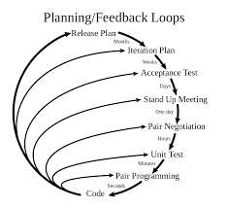

https://upload.wikimedia.org/wikipedia/commons/thumb/8/84/Extreme_Programming.svg/1200px-Extreme_Programming.svg.png

### **Extreme Programming (XP):**

Extreme Programming is another subclass of the agile development framework and is specifically designed for software development projects. XP is distinguished for its immense focus on adaptability rather than on predictability. This is because of fluid nature of software development in general where requirements cannot be fully predicted from the beginning and will constantly changing as the project moves on. XP consists of very little to no documentation during the process and instead XP programmers start to generate code from the very beginning while listening to the customer. As a result, XP developers need to be naturally good listeners to enable them to understand and develop solutions which match the customers’ needs and desires as close as possible. XP emphasises on the testing the function of the system and so tests are pre-written and then the application code is development to pass those initial challenges of the test, further tests are also written to try and break the code.

*Figure 5 – XP Model*

#### Advantages:

XP is extremely fast-paced and so instead of taking a couple of years to complete a project, like in waterfall, XP projects only lasts for several months. This is because there is continuous integration and testing rather than a ‘big bang’ in the waterfall approach. Additionally, there is no wasting time writing lots of documentation that are often never used or seen again, further reducing the development lifecycle. This also benefits the developers as they will be much happier writing code rather than writing documentation leading to them being more creative during the design and development process. In XP, changing requirements are swiftly implemented throughout the development period, this reduces costs as it reduces the risk of a complete redevelopment.

#### Disadvantages:

XP consists of a very fast-paced work environment and so demands for a highly motivated, stable and experienced development team who can rapidly translate the customers’ words into a working software package. XP takes customer/user involvement to the extreme as they must always be on-site to answer questions and ensure that the software being developed is in line with their wishes. Due to little documentation in XP, constant changes are not kept track of, causing unexpected failures to occur and even when bugs are resolved, without accurate records, same errors may recur. XP can also be very stressful as developers have to keep to tight deadlines. This stress may cause them to make more mistakes, diminishing the quality of the final product leaving an unsatisfied user/customer.

## **Chosen Methodology**

I have chosen to pursue the traditional waterfall approach for my project, as I feel it is the most suitable for designing and developing a part of the new management system for JD Dog Care. The first reason being that I will be pursuing this task alone with minor collaboration with others and so this process eliminates most of the agile methodologies as they encourage a fully dedicated team of highly skilled developers to divide and complete the workload, leaving only the waterfall approach to be the most suitable. JD Dog Care already has an existing manual system in place and so the Waterfall methodology is the most appropriate to deal with implementing a manual system into software system with already existing and fully defined requirements for their system. The Waterfall model is easy to understand and follow for developers with minimal experience in the world of work, such as myself, and so I will be more proficient with the easy to follow, step by step sequential flow of the waterfall method. JD Dog Care has clear, well defined and mostly unchanging requirements for its software system and reliability in the system is somewhat critical for John and Diane to ensure smooth operations in their ever-growing business and hence, the Waterfall Methodology ensures that a successful software package of the highest quality will be delivered on time for the business owners.

## **Chosen Project Area**

Taking the limited resources and time constraints into account, I plan to focus on one area of the JD Dog Care Administration System to ensure the final product is of the highest quality. I have decided to tackle the Dog Grooming Services that JD Dog Care provides as this serves as the main foundation that the system can be built and expanded upon. The Dog Grooming Service was one of the first things that John and Diane have been and are still providing since the opening of the business and is one of the main things that put them on the map. For this reason, I believe that developing a software system to aid with this part of the business is vital to keep the business running and growing. As such, I will be developing an easy to use system to register and update clients and their dogs, as well as the staff members to allow for the business to grow. The system must also include ways to create and update bookings for grooming appointments and calculate relevant payments due.

## **Gantt Charts**

# Design

## **User Requirements**

### **General Requirements**

1. The software system must be user-friendly and easy to navigate around for new staff members pick up quickly.
2. All text in the application should be the correct size and font and use simple language to be easily read by members of staff from all backgrounds and ages.
3. The layout of all parts of the system should be consistent with each other to make it easy to follow.
4. The application should be aesthetically pleasing to the eye and have a modern design with various colours and mechanics ensuring that it is not too colourful to be distracting or include too many mechanics that it is too complicated to use.
5. All data that is entered into the application must be validated before it is entered into the database to ensure that all data is entered and there are valid according to the system.

### **Main Menu**

1. The Main Menu Form should act as the main hub and therefore must contain buttons to access the rest of the application to register and update a client, dog or staff record in the database as well as buttons to create and edit a booking of a grooming appointment and each of their payment details. A button to see payment reports should also be present.
2. A title must be present above every page and should change along with the button presses so the user can quickly identify what screen they are currently on.
3. The latest button that was clicked on the main menu must be highlighted as another way for the user to easily identify which screen is currently showing.
4. A toolbar must be present on top of each page containing buttons to the other pages inside the current screen. For instance, once the Register button is clicked, a toolbar containing Client, Dog and Staff should be displayed for the user to easily switch between registering a client to registering their dog etc.
5. The latest button pressed on the toolbar should be highlighted and colour-coded to the same colour as the current page displayed. (E.g. Client button should be highlighted when on Client page).
6. The user must be provided with a means to exit the application or minimise and so the main menu must host a minimise and close buttons.

### **Home**

### **Client**

* 1. The Client Screen must have two possible states: one for Registering/Adding client records and another for Updating/Editing existing client records in the database.
  2. In the registering and updating screen, the user must be able to enter or change relevant details of the new client onto the data fields with each of them being labelled appropriately to ensure easy navigation.
  3. The next available Client ID number must be automatically displayed when registering a new client to avoid errors and data inconsistency.
  4. In the updating screen, there must be a way to search for existing clients and show their details on the data fields so that they can be updated. Buttons should be present to navigate through adjacent client records in order of their Client ID number.
  5. In the updating screen, there must be a way for the user to delete an existing client after they have searched for them and a message should be shown notifying a successful operation.
  6. In both the registering and updating screens, error providers must flash when invalid data is entered into the fields and the record must not be allowed to be registered or updated if any of its values is invalid. All fields will be required to be filled.
  7. The Client ID number should always be in text format and have 4 characters. To avoid confusion and errors this text field should be set to read only to prohibit the user from changing it.
  8. The Forename and Surname text fields must only contain letters and/or an apostrophe (e.g. O’Doherty) and should only allow a maximum of 30 characters. Errors with accompanying messages should be displayed if invalid.
  9. The Sex text field should be a selection box so the user cannot enter anything other than ‘Male’, ‘Female’ or ‘Other’. Errors should be displayed if invalid.
  10. The user should not be able to enter clients that are under 18 years of age or an age that is unrealistic so this must be checked in the Date of Birth field. Errors should flash notifying the user if an invalid date is entered.
  11. The Address text field should only allow letters and numbers and values entered should not exceed 50 characters otherwise errors will be displayed.
  12. The City/Town text field should only allow letters and forward slashes (‘/’) and values with a max of 50 characters otherwise errors will be displayed.
  13. The client’s Postcode should be entered in the correct UK Postcode format (‘LLNN NLL’) to be passed through or errors will be revealed with a user-friendly message.
  14. The E-mail text field should consist of a valid e-mail address (somenone@email.com), no more than 50 characters and containing no white spaces otherwise errors will be displayed notifying where the user went wrong.
  15. The Phone Number text field should allow between 11 and 15 characters long consisting of only numbers and maybe a plus character (‘+’) at the start. Errors will be shown if invalid.
  16. The Date Joined should be automatically set to the current date when registering a new client. It can be changed when updating however the user should not be able to set the date to a future date. Errors should be shown if this is the case.
  17. In the registering screen, after a successful Client registration, the user should automatically be transferred to the Dog Registration page to add a dog owned by the new client.
  18. In the updating screen, there should be a way to show and quickly go to the dogs owned by the current client displayed.

### **Dog**

1. The Dog Screen should have two possible states: one for Registering/Adding dog records and another for Updating/Editing details of existing dog records in the database.
2. In the registering and updating screen, the user must be able to enter or change relevant details of the new dog onto the data fields with each of them being labelled appropriately to ensure easy navigation.
3. The next available Dog ID number must be automatically displayed when registering a new dog to avoid errors and data inconsistency.
4. In the updating screen, there must be a way to search for existing dogs and show their details on the data fields so that they can be updated. Buttons should be present to navigate through adjacent dog records in order of their Dog ID number.
5. In the updating screen, there must be a way for the user to delete an existing dog after they have searched for them and a message should be shown notifying a successful deletion.
6. On the updating screen, there must be an image for each dog that is being displayed so the they can be easily be identified and searched for, plus it will give a professional look to the application.
7. In both the registering and updating screens, error providers must flash when invalid data is entered into the fields and the record must not be allowed to be registered or updated if any of its values is invalid. All fields will be prohibited to be left empty.
8. The Dog ID number should always be in text format and have 4 characters. To avoid confusion and errors this text field should be set to read only to prohibit the user from changing it.
9. The client/owner’s name must only permit clients that are already registered into the system. Any foreign clients should elicit an error being displayed.
10. The name text field must only permit letters and a maximum of 30 characters or errors with messages will be displayed.
11. The breed text field should only permit letters and/or white spaces and a maximum of 30 characters otherwise error providers will be shown.
12. The sex text field should be a selection box so the user cannot enter anything other than ‘Male’ or ‘Female’. Errors should be displayed if invalid.
13. The date of birth of the dog should be realistic and so the user should not be allowed to set it to a future date or a date 50 years before the current date. Errors should display if this happens.
14. The additional medical notes of the dog should not be left void and so if the user does not enter any value than it should be automatically set to ‘None’ to avoid any errors.
15. There must be a button to look at and update the dog’s vaccination history listing all the vaccinations the dog has received and when.

### **Staff**

1. The Staff Screen should have two initial states: one for Registering/Adding staff records and another for Updating/Editing existing staff member records in the database.
2. In the registering and updating screen, the user must be able to enter or change relevant details of the new staff member onto the data fields with each of them being labelled appropriately to ensure easy navigation.
3. The next available Staff ID number must be automatically displayed when registering a new staff member to avoid errors and data inconsistency.
4. In the updating screen, there must be a way to search for existing members of staff and show their details on the data fields so that they can be updated. Buttons should be present to navigate through adjacent staff records in order of their Staff ID number.
5. In the updating screen, there must be a way for the user to delete an existing staff member after they have searched for them and a message should be shown notifying a successful operation.
6. In both the registering and updating screens, error providers must flash when invalid data is entered into the fields and the record must not be allowed to be registered or updated if any of its values is invalid. All fields will be required to be filled.
7. The Staff ID number should always be in text format and have 4 characters. To avoid confusion and errors this text field should be set to read only to prohibit the user from changing it.
8. The forename and surname text fields must only contain letters and/or an apostrophe (e.g. O’Doherty) and should only allow a maximum of 30 characters. Errors with accompanying messages should be displayed if invalid.
9. The sex text field should be a selection box so the user cannot enter anything other than ‘Male’, ‘Female’ or ‘Other’. Errors should be displayed if not correct.
10. The user should not be able to enter clients that are under 16 years of age or an age that is unrealistic so this must be checked in the date of birth field. Errors should flare notifying the user if an invalid date is entered.
11. The address text field should only permit letters and numbers. Values entered should not exceed 50 characters otherwise errors will be displayed.
12. The city/town text field should only allow letters and forward slashes (‘/’) and values with a max of 50 characters otherwise errors will be shown.
13. The client’s postcode should be entered in the correct UK Postcode format (‘LLNN NLL’) to be passed through or errors will be revealed with a helpful message.
14. The e-mail text field should consist of a valid e-mail address (somenone@email.com), no more than 50 characters and containing no white spaces otherwise errors will be displayed notifying where the user went wrong.
15. The phone number text field should allow between 11 and 15 characters long consisting of only numbers and maybe a plus character (‘+’) at the start. Errors will be shown if it does not follow these rules.
16. The user must tick one of the check boxes either ‘Full-Time’ or ‘Part-Time’ for the type of job contract the staff member currently is on or else errors will flash and prevent the user from carrying on.
17. The job position describes the specific job the staff members does and so the user will have to pick one of the following: ‘Management’, ‘Administration’ or ‘Grooming’ in order to continue without error.
18. The salary should only permit up to a maximum of 10 digits and should be stored to two decimal places. If the user sways away from these constraints, errors must be shown, and the user must be prevented from continuing further.
19. The date joined should be automatically set to the current date when registering a new staff employee. It can be changed when updating however the user should not be able to set the date to a future date. Errors should be shown if this is the case.

### **Booking**

1. The Booking Screen should have two initial forms: one for Creating/Adding new booking records and another for Updating/Editing existing booking records in the database.
2. In the create booking screen, the user must be able to enter relevant details of the new booking onto the data fields with each of them being labelled appropriately to ensure easy understanding.
3. The next available Booking Number must be automatically displayed when booking a new appointment to avoid errors and data inconsistency.
4. In the updating screen, there must be a way to search for existing bookings and show their details in a table/grid so that they can be selected with ease. Different bookings can be for the same dogs which can be confusing for the user.
5. In the updating screen, there must be a way for the user to delete an existing booking record after they have searched for them and a message should be shown notifying a successful operation.
6. In both the create booking and updating screens, error providers must flash when invalid data is entered into the fields and the record must not be allowed to be recorded or updated if any of its values is invalid. All fields will be required to be filled.
7. The Booking Number should always be in text format and have 4 characters. To avoid confusion and errors this text field should be set to read only to prohibit the user from changing it.
8. The user should be only permitted to enter names of dogs that already exist in the database and this should automatically fill the selection box for the client’s name with the full names of clients that own a dog with this name. Both the dog’s name and its owner’s name values should be used to automatically search for their Dog ID number.
9. Under the Create Booking state, the user should only be allowed to set the date of the appointment in the future or the present date. Errors should be shown if this is disobeyed. Also, the user should not be able to book an appointment more than 6 months from the present.
10. The user should only be permitted to set the start time of the appointment within the working hours at JD Dog Care otherwise errors will display. Additionally, under the Create Booking state, if the date of the appointment is set to the present day, the start time should forbid times that are before the current time.
11. The service option for the booking should only allow the three options that JD Dog Care employ to be selected or errors must flash. The extra option for nails, teeth and ears should be check box where the user can select or deselect it depending on the client’s choice. The duration and price for the booking should automatically update when the option is selected as well as when the extra option is checked or unchecked.
12. Under the Create Booking state, if this is the first booking for this client then the extra fee of 15 minutes and £5 should be added to the duration and price of the booking respectively.
13. The staff name should only permit staff members that work at JD Dog Care and their Staff ID number should be only automatically found and set to the current booking otherwise errors should display.
14. The date created should be automatically set to the current date when creating a new booking. It can be changed when updating however the user should not be able to set the date to a date after the date of the appointment. Errors should be shown if this is the case.

### **Payment**

1. The Payment Screen should have two possible states: one for searching for payment details about a particular booking and another for viewing and Creating/Updating a payment record to the database.

### **Vaccination**

### **Service Option**

### **Reports**

## **Database Design**

### **Normalisation**

#### **0NF:**

**JDDOGCARE** (BookingNo, DogID, DName, DBreed, DSex, DDOB, DMedicalNotes,

VaccinationNo, VName, VDate, ClientID, CForename, CSurname, CSex, CDOB, CAddress,

CCity, CPostcode, CEmail, CPhoneNo, CDateJoined, BDate, BStartTime, ServiceOption,

SODescription, SODuration, SOPrice, BExtraOption, StaffID, SForename, SSurname, SSex,

SDOB, SAddress, SCity, SPostcode, SEmail, SPhoneNo, SJobContract, SJobPostion,

SSalary, SDateJoined)

**ER Diagram**

### **UML Diagram**

### **Data Dictionary**

## **UI Design**

### **Initial Sketches**

#### **Main Menu**

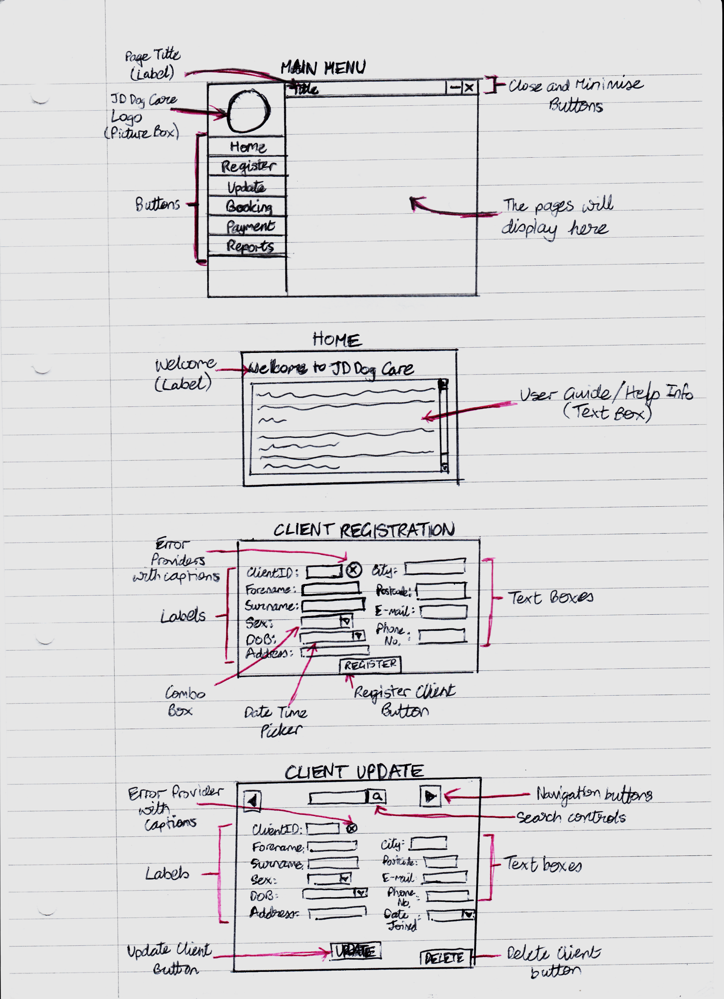

#### **Home**

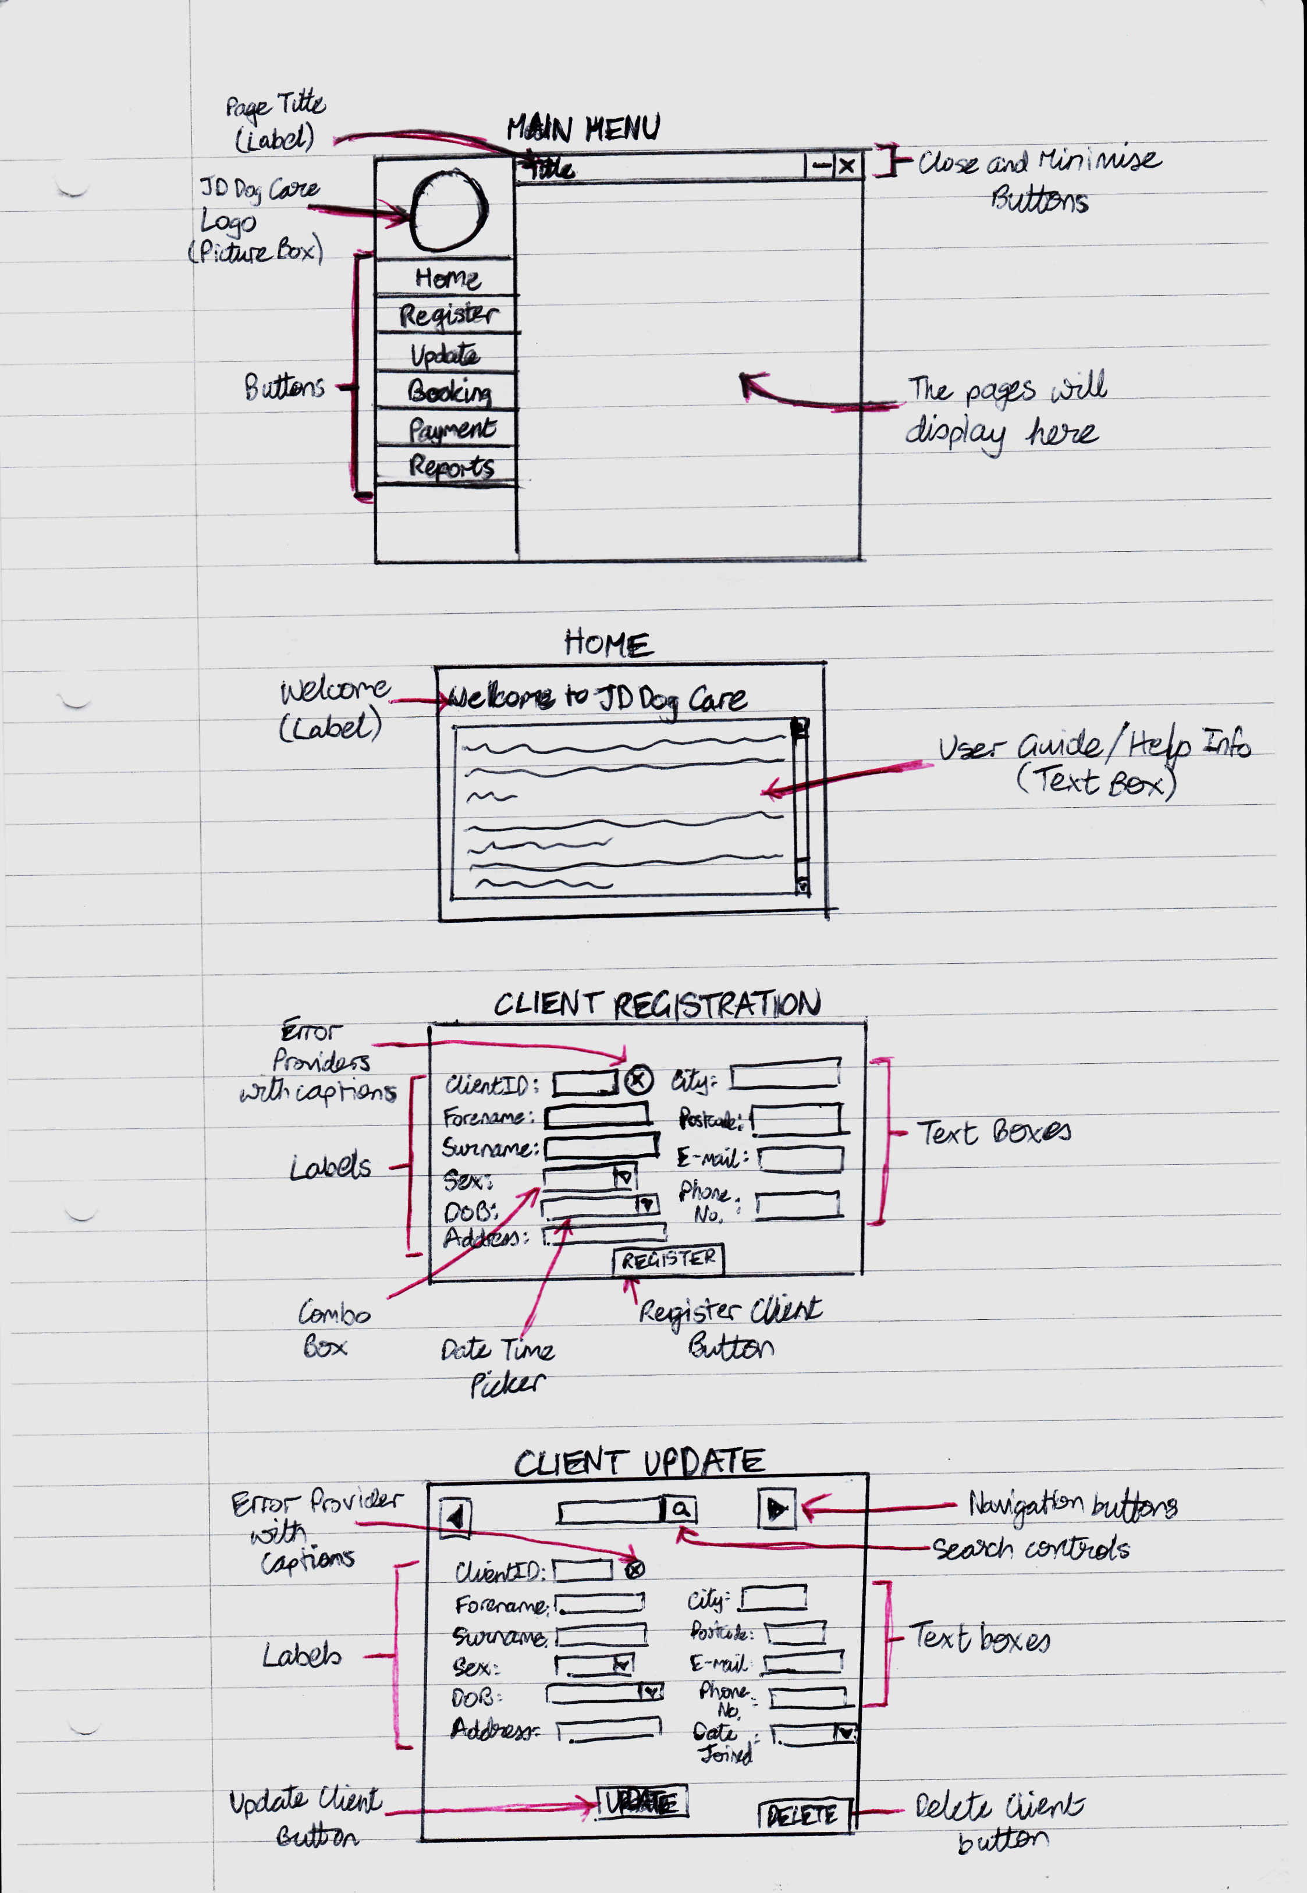

#### **Client**

##### *Register*

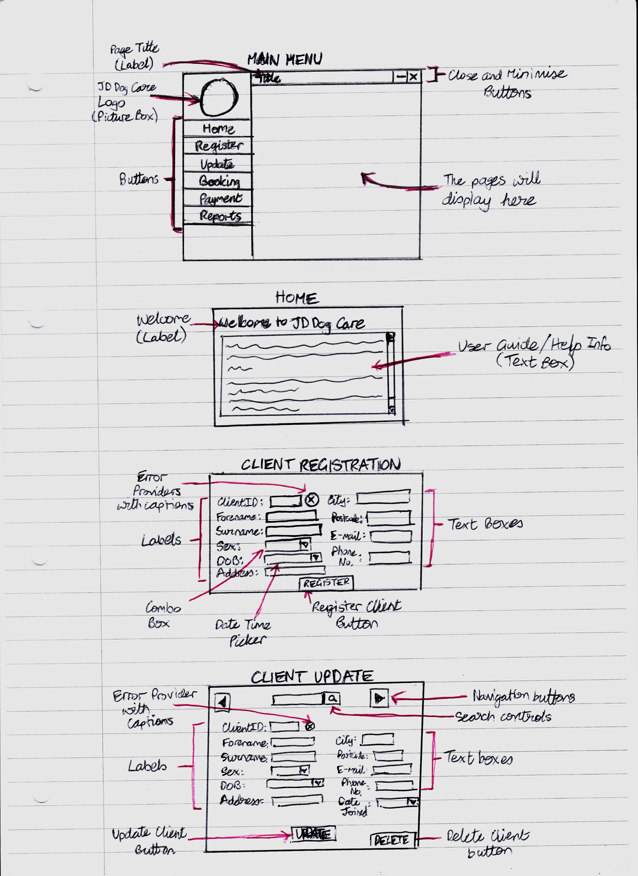

##### *Update*

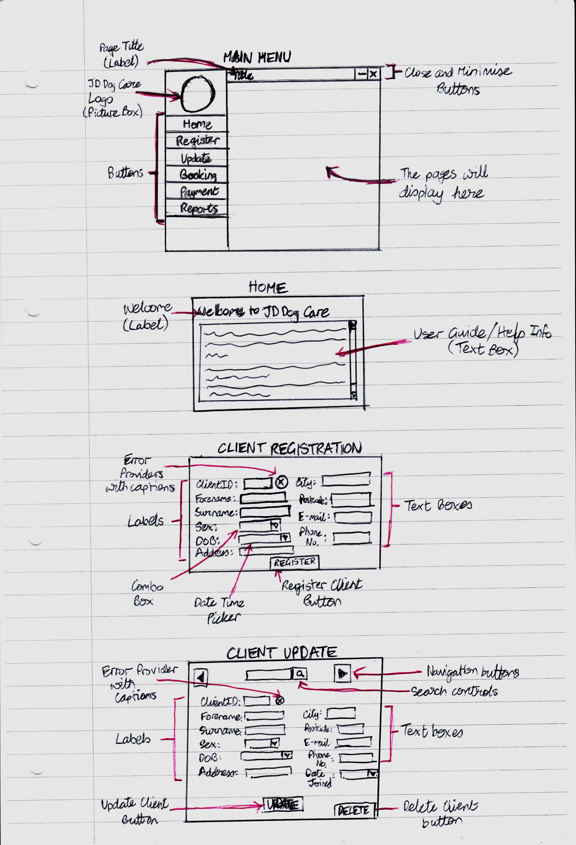

#### **Dog**

*Register*

##### *Update*

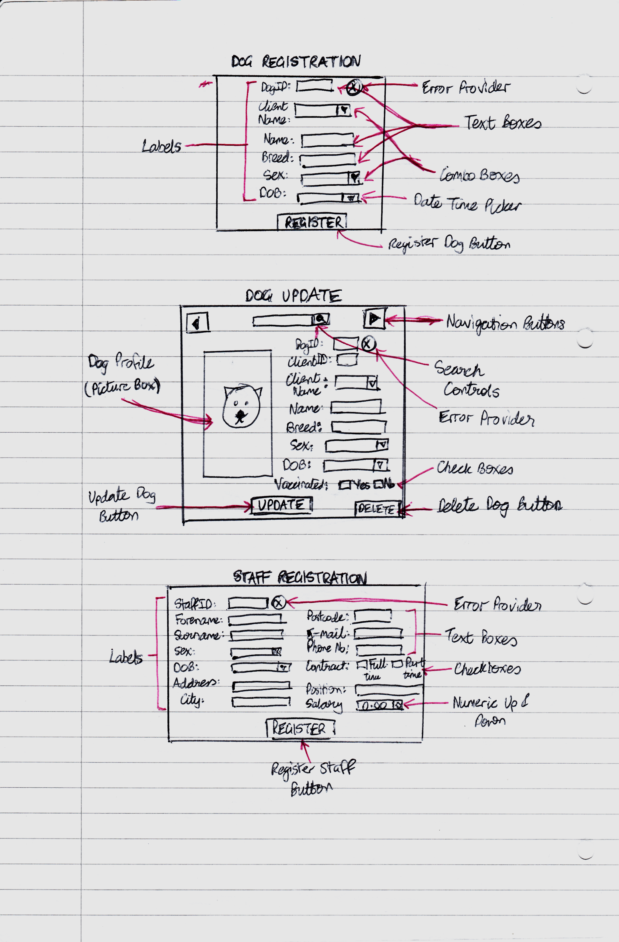

#### **Staff**

*Register*

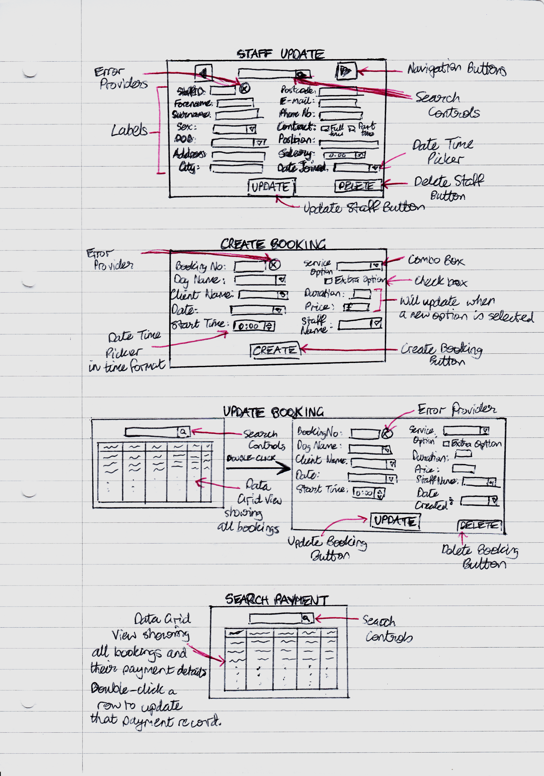

##### *Update*

#### **Booking**

*Create*

##### *Update*



#### **Payment**

*Search*

##### *View*

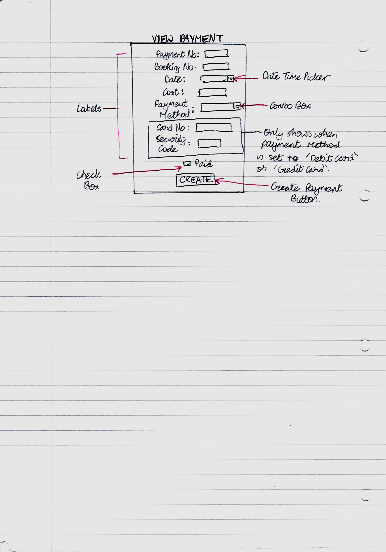

### **Wireframes**

#### **Main Menu**

**-**

**x**

Register

Update

Booking

Home

Reports

**5)** btnHome

**6)** btnRegister

**7)** btnUpdate

**8)** btnBooking

**9)** btnReports

**2)** pSide

**Title**

**10)** lblTitle

**3)** pTop

**1)** FrmJDDogCare

**11)** btnMinimise

**12)** btnExit

**4)** pbJDDogCareLogo

All text present in the application will have font ‘Century Gothic’ to keep consistency.

1. **FrmJDDogCare:** This will be the main menu screen and the first screen the user will be greeted with. All parts of the application will be accessed through and displayed here.
2. **pSide:** This side panel will hold the JD Dog Care Logo and all the buttons to access the other forms.
3. **pTop:** This top panel will hold the title and the minimise and close buttons.
4. **pbJDDogCareLogo:** This will display the company logo.
5. **btnHome:** This button will display the home page onto the form.
6. **btnRegister:** This button will display the registering screen to register a record.
7. **btnUpdate:** This button will display the updating screen to update a record.
8. **btnBooking:** This button will display the booking screen to create or update a booking record.
9. **btnReports:** This button will display the reports.
10. **lblTitle:** This label will display the title of the current page (e.g. Booking).
11. **btnMinimise:** This button will minimise the application to the taskbar.
12. **btnExit:** This button will completely close the application.

|  |  |  |  |
| --- | --- | --- | --- |
| Control | Properties | Value | Events |
| Form | Name  FormBorderStyle  Size  StartPosition | FrmJDDogCare  None  1000 x 620 (px)  CentreScreen | N/A |
| Panel | Name  Size | pSide  240 x 440 (px) | N/A |
| Panel | Name  Size | pTop  760 x 40 (px) | N/A |
| Picture Box | Name  Size | pbJDDogCareLogo  240 x 220 (px) | N/A |
| Button | Name  Text  Cursor  FlatStyle | btnHome  Home  Hand  Flat | BtnHome_Click |
| Button | Name  Text  Cursor  FlatStyle | btnRegister  Register  Hand  Flat | BtnRegister_Click |
| Button | Name  Text  Cursor  FlatStyle | btnUpdate  Update  Hand  Flat | BtnUpdate_Click |
| Button | Name  Text  Cursor  FlatStyle | btnBooking  Booking  Hand  Flat | BtnBooking_Click |
| Button | Name  Text  Cursor  FlatStyle | btnReports  Reports  Hand  Flat | BtnReports_Click |
| Label | Name  Text | lblTitle  Home | N/A |
| Button | Name  Text  FlatStyle | btnMinimise  -  Flat | BtnMinimise_Click |
| Button | Name  Text  FlatStyle | btnExit  ×  Flat | BtnExit_Click |

#### **Home**

#### **Client**

##### Register

**ClientID:**

**Forename:**

**Surname:**

**Sex:**

**DOB:**

**Address:**

**Register**

**Date Joined:**

**Postcode:**

**E-mail:**

**Phone No:**

**1)** UcClient

**2)** lblClientID

**3)** txtClientID

**4)** lblForename

**5)** txtForename

**6)** lblSurname

**7)** txtSurname

**8)** lblSex

**9)** cbSex

**10)** lblDOB

**11)** dtpDOB

**12)** lblAddress

**13)** txtAddress

**16)** lblPostcode

**17)** txtPostcode

**18)** lblEmail

**19)** txtEmail

**20)** lblPhoneNo

**21)** txtPhoneNo

**22)** lblDateJoined

**23)** dtpDateJoined

**24)** btnClient

**City/Town:**

**14)** lblCity

**15)** txtCity



**25)** ep

1. **UcClient:** This User Control will be displayed when user clicks the Register button on the main menu and then the Client button.

**2), 4), 6), 8), 10), 12), 14), 16), 18), 20), 22) Labels:** Indicates what the text field adjacent is for.

**3), 5), 7), 13), 15), 17), 19), 21) Text Boxes:** User will have to enter data about the client into these text fields.

1. **cbSex:** Combo box where user will have to select the client’s sex out of the options: Male, Female and Other.

**11), 23) Date Time Pickers:** The user will have to select the date of birth of the client on an interactive calendar. The date joined will already be set to the current date so will be disabled so the user cannot change it.

1. **btnClient:** Button that will validate and then register a client record holding all the data entered to the database.
2. **ep:** Error provider that will display on input fields that are invalid.

|  |  |  |  |
| --- | --- | --- | --- |
| Control | Properties | Value | Events |
| User Control | Name  Size | UcClient  760 x 550 (px) | N/A |
| Label | Name  Text | lblClientID  ClientID: | N/A |
| Text Box | Name  ReadOnly | txtClientID  True | TxtClientID_TextChanged |
| Label | Name  Text | lblForename  Forename: | N/A |
| Text Box | Name | txtForename | TxtForename_TextChanged |
| Label | Name  Text | lblSurname  Surname: | N/A |
| Text Box | Name | txtSurname | TxtSurname_TextChanged |
| Label | Name  Text | lblSex  Sex: | N/A |
| Combo Box | Name  Items | cbSex  [Male, Female, Other] | CbSex_TextChanged |
| Label | Name  Text | lblDOB  Date Of Birth: | N/A |
| Date Time Picker | Name  Format | dtpDOB  Short | DtpDOB_ValueChanged |
| Label | Name  Text | lblAddress  Address: | N/A |
| Text Box | Name | txtAddress | TxtAddress_TextChanged |
| Label | Name  Text | lblCity  City/Town: | N/A |
| Text Box | Name | txtCity | TxtCity_TextChanged |
| Label | Name  Text | lblPostcode  Postcode: | N/A |
| Text Box | Name | txtPostcode | TxtPostcode_TextChanged |
| Label | Name  Text | lblEmail  E-mail: | N/A |
| Text Box | Name | txtEmail | TxtEmail_TextChanged |
| Label | Name  Text | lblPhoneNo  Phone No: | N/A |
| Text Box | Name | txtPhoneNo | TxtPhoneNo_TextChanged |
| Label | Name  Text | lblDateJoined  Date Joined: | N/A |
| Date Time Picker | Name  Format | dtpDateJoined  Short | DtpDateJoined_ValueChanged |
| Button | Name  Text  Cursor  FlatStyle | btnClient  Register  Hand  Flat | BtnClient_Click |
| Error Provider | Name | ep | N/A |

##### Update

**ClientID:**

**Forename:**

**Surname:**

**Sex:**

**DOB:**

**Address:**

**Update**

**Date Joined:**

**Postcode:**

**E-mail:**

**Phone No:**

**1)** UcClient

**2)** lblClientID

**3)** txtClientID

**4)** lblForename

**5)** txtForename

**6)** lblSurname

**7)** txtSurname

**8)** lblSex

**9)** cbSex

**10)** lblDOB

**11)** dtpDOB

**12)** lblAddress

**13)** txtAddress

**16)** lblPostcode

**17)** txtPostcode

**18)** lblEmail

**19)** txtEmail

**20)** lblPhoneNo

**21)** txtPhoneNo

**22)** lblDateJoined

**23)** dtpDateJoined

**24)** btnClient

◄

►

**28)** btnPrevious

**26)** txtSearch

**27)** btnSearch

**29)** btnNext

**View Dogs Owned**

**Delete Client**

**31)** btnDelete

**30)** btnViewClientDogs

**City/Town:**

**14)** lblCity

**15)** txtCity



**25)** ep

**32)** dgvDogsOwned

1. **UcClient:** This User Control will be displayed when user clicks the Update button on the main menu and then the Client button.

**2) – 25) Refer to page ~16~**

**26), 27) Search Text Box and Button:** Controls that can be used to search for a client by inputting their surname and forename

**28), 29) Next and Previous Buttons:** Buttons that can be used to navigate through all the clients in order of their ClientID.

1. **btnViewClientDogs:** Button that will display a table [**30)**] with all the dogs that the current client owns.
2. **btnDelete:** Button that will delete the current client displayed and their dogs from database
3. **dgvDogsOwned:** Data Grid View that will be displayed when btnViewDogsOwned [**30)**] is clicked. It will show a table with all the dogs owned by the client. The dog records can be double clicked to quickly transfer to its update screen.

|  |  |  |  |
| --- | --- | --- | --- |
| Control | Properties | Value | Events |
| User Control | Name  Size | UcClient  760 x 550 (px) | N/A |
| Label | Name  Text | lblClientID  ClientID: | N/A |
| Text Box | Name  ReadOnly | txtClientID  True | TxtClientID_TextChanged |
| Label | Name  Text | lblForename  Forename: | N/A |
| Text Box | Name | txtForename | TxtForename_TextChanged |
| Label | Name  Text | lblSurname  Surname: | N/A |
| Text Box | Name | txtSurname | TxtSurname_TextChanged |
| Label | Name  Text | lblSex  Sex: | N/A |
| Combo Box | Name  Items | cbSex  [Male, Female, Other] | CbSex_TextChanged |
| Label | Name  Text | lblDOB  Date Of Birth: | N/A |
| Date Time Picker | Name  Format | dtpDOB  Short | DtpDOB_ValueChanged |
| Label | Name  Text | lblAddress  Address: | N/A |
| Text Box | Name | txtAddress | TxtAddress_TextChanged |
| Label | Name  Text | lblCity  City/Town: | N/A |
| Text Box | Name | txtCity | TxtCity_TextChanged |
| Label | Name  Text | lblPostcode  Postcode: | N/A |
| Text Box | Name | txtPostcode | TxtPostcode_TextChanged |
| Label | Name  Text | lblEmail  E-mail: | N/A |
| Text Box | Name | txtEmail | TxtEmail_TextChanged |
| Label | Name  Text | lblPhoneNo  Phone No: | N/A |
| Text Box | Name | txtPhoneNo | TxtPhoneNo_TextChanged |
| Label | Name  Text | lblDateJoined  Date Joined: | N/A |
| Date Time Picker | Name  Format | dtpDateJoined  Short | DtpDateJoined_ValueChanged |
| Button | Name  Text  Cursor  FlatStyle | btnClient  Update  Hand  Flat | BtnClient_Click |
| Error Provider | Name | ep | N/A |
| Text Box | Name  AutoCompleteMode | txtSearch  SuggestAppend | N/A |
| Button | Name  Icon | btnSearch  [Search Icon] | BtnSearch_Click |
| Button | Name  Text | btnPrevious  ◄ | BtnPrevoius_Click |
| Button | Name  Text | btnNext  ► | BtnNext_Click |
| Button | Name  Text | btnViewClientDogs  View Dogs Owned | BtnViewClientDogs_Click |
| Button | Name  Text | btnDelete  Delete Client | BtnDelete_Click |
| Data Grid View | Name  Location  Size  Visible | dgvDogsOwned  20 x 85 (px)  720 x 360 (px)  False | DgvDogsOwned_CellContent  DoubleClick |

#### **Dog**

##### Register

**8)** lblBreed

**9)** txtBreed

**2)** lblDogID

**3)** txtDogID

**DogID:**

**Client Name:**

**Sex:**

**DOB:**

**Name:**

**Register**

**1)** UcDog

**4)** lblClientName

**5)** cbClientName

**6)** lblName

**7)** txtName

**12)** lblDOB

**13)** dtpDOB

**14)** btnDog

**10)** lblSex

**11)** cbSex

**Breed:**



**15)** ep

1. **UcDog:** This User Control will be display when the user clicks the Register button on the main menu screen and then the Dog button.

**2), 4), 6), 8), 10), 12) Labels:** Indicate the what the text field adjacent is for.

**3), 7), 9) Text Boxes:** User must enter data about the client into these text fields.

1. **cbClientName:** Combo box will hold all the client’s names currently in the database and the user will simply have to choose the appropriate client that owns this new dog.
2. **cbSex:** Combo box where user will have to select the dog’s sex out of the options: Male and Female.
3. **dtpDOB:** The user will have to select the date of birth of the dog on an interactive calendar.
4. **btnDog:** This button will validate and then register a dog record holding all the data entered to the text fields.
5. **ep:** Error provider that will display on input fields that are invalid.

|  |  |  |  |
| --- | --- | --- | --- |
| Control | Properties | Value | Events |
| User Control | Name  Size | UcDog  760 x 550 (px) | N/A |
| Label | Name  Text | lblDogID  DogID: | N/A |
| Text Box | Name  ReadOnly | txtDogID  True | TxtDogID_TextChanged |
| Label | Name  Text | lblClientName  Client Name: | N/A |
| Combo Box | Name | cbClientName | CbClientName_TextChanged |
| Label | Name  Text | lblName  Name: | N/A |
| Text Box | Name | txtName | TxtName_TextChanged |
| Label | Name  Text | lblBreed  Breed: | N/A |
| Text Box | Name | txtBreed | TxtBreed_TextChanged |
| Label | Name  Text | lblSex  Sex: | N/A |
| Combo Box | Name  Items | cbSex  [Male, Female] | CbSex_TextChanged |
| Label | Name  Text | lblDOB  Date Of Birth: | N/A |
| Date Time Picker | Name  Format | dtpDOB  Short | DtpDOB_ValueChanged |
| Button | Name  Text  Cursor  FlatStyle | btnDog  Register  Hand  Flat | BtnDog_Click |
| Error Provider | Name | ep | N/A |

##### Update

**ClientID:**

**Client Name:**

**Sex:**

**DOB:**

**Name:**

**Update**

**1)** UcDog

**4)** lblClientName

**5)** cbClientName

**6)** lblName

**7)** txtName

**12)** lblDOB

**13)** dtpDOB

**14)** btnDog

**10)** lblSex

**11)** cbSex

**Breed:**

**2)** lblDogID

**3)** txtDogID

**8)** lblBreed

**9)** txtBreed

**DogID:**

**21)** pbDogProfile

◄

►

**24)** btnPrevious

**22)** txtSearch

**23)** btnSearch

**25)** btnNext

**View Vaccination Histroy**

**Delete Dog**

**27)** btnDelete

**26)** btnView

Vaccination

History

**16)** lblClientID

**17)** txtClientID

**Medical Notes:**

**20)** rtxtMedical

Notes

**19)** lblMedical

Notes

**View Medical Notes**

**18)** btnView

MedicalNotes



**15)** ep

1. **UcDog:** This User Control will be display when the user clicks the Update button on the main menu screen and then the Dog button.

**2) - 15) Refer to page ~21~**

**16), 19) Labels:** Indicate the what the text field adjacent is for.

1. **txtClientID:** Read only text field that will update when the user selects a client name in cbClientName [**5)**].
2. **btnViewMedicalNotes:** Button that when clicked will hide the dog profile picture box [**23)**] and show the label and rich text box for medical notes [**21) & 22)**].
3. **rtxtMedicalNotes:** Rich text box where user will be able to enter medical notes for the dog. If there are none, ‘None’ will be returned as the default.
4. **pbDogProfile:** Picture box that will show a profile of the current dog presented.

**22), 23) Search Text Box and Button:** Controls that will be able to search for a dog by inputting their name followed by their client’s surname and forename.

**24), 25) Next and Previous Buttons:** Buttons that can be used navigate through all the dog records in order of their DogID.

1. **btnViewVaccinationHistory:** Button that when clicked will hide all controls and show the DogVaccinationHistroy screen to show the current dog’s vaccination history.
2. **btnDelete:** Button that will delete the current dog displayed from the database.

|  |  |  |  |
| --- | --- | --- | --- |
| Control | Properties | Value | Events |
| User Control | Name  Size | UcDog  760 x 550 (px) | N/A |
| Label | Name  Text | lblDogID  DogID: | N/A |
| Text Box | Name  ReadOnly | txtDogID  True | TxtDogID_TextChanged |
| Label | Name  Text | lblClientName  Client Name: | N/A |
| Combo Box | Name | cbClientName | CbClientName_TextChanged |
| Label | Name  Text | lblName  Name: | N/A |
| Text Box | Name | txtName | TxtName_TextChanged |
| Label | Name  Text | lblBreed  Breed: | N/A |
| Text Box | Name | txtBreed | TxtBreed_TextChanged |
| Label | Name  Text | lblSex  Sex: | N/A |
| Combo Box | Name  Items | cbSex  [Male, Female] | CbSex_TextChanged |
| Label | Name  Text | lblDOB  Date Of Birth: | N/A |
| Date Time Picker | Name  Format | dtpDOB  Short | DtpDOB_ValueChanged |
| Button | Name  Text  Cursor  FlatStyle | btnDog  Register  Hand  Flat | BtnDog_Click |
| Error Provider | Name | ep | N/A |
| Label | Name  Text | lblClientID  ClientID: | N/A |
| Text Box | Name  ReadOnly | txtClientID  True | TxtClientID_TextChanged |
| Button | Name  Text | btnViewVaccinationHistory  View Vaccination History | BtnViewVaccinationHistory_  Click |
| Label | Name  Text | lblMedicalNotes  Medical Notes: | N/A |
| Rich Text Box | Name  Size | rtxtMedicalNotes  265 x 220 (px) | RtxtMedicalNotes_  TextChanged |
| Picture Box | Name  Size | pbDogProfile  265 x 280 (px) | N/A |
| Text Box | Name  AutoCompleteMode | txtSearch  SuggestAppend | N/A |
| Button | Name  Icon | btnSearch  [Search Icon] | BtnSearch_Click |
| Button | Name  Text | btnPrevious  ◄ | BtnPrevoius_Click |
| Button | Name  Text | btnNext  ► | BtnNext_Click |
| Button | Name  Text | btnViewMedicalNotes  View Dogs Owned | BtnViewMedicalNotes  _Click |
| Button | Name  Text | btnDelete  Delete Dog | BtnDelete_Click |

#### **Dog Vaccination History**

**1)** UcDogVaccinationHistory

**2)** dgvVaccinationHistory

**3)** lblVaccinationName

**4)** cbVaccinationName

**5)** lblVaccinationDate

**6)** dtpVaccinationDate

**Name:**

**Date:**

**7)** btnUpdateVaccination

**Update**

1. **UcDogVaccinationHistory:** This User Control will be display when the user clicks the View Vaccination History button on the Update Dog page.
2. **dgvVaccinationHistory:** This Data Grid View will show all the vaccinations that the current dog has received as well as the date received. It can be double clicked to quickly fill the input fields for a vaccination the user wants to update.

**3), 5) Labels:** Indicate the what the input field adjacent is for.

1. **cbVaccinationName:** This Combo Box will hold all the vaccination names that is mandatory for a dog to receive.
2. **dtpVaccinationDate:** This Date Time Picker can be set to a date when the dog had received the named vaccination in cbVaccinationName [**4)**]. This will set to ‘NULL’ if the dog has not received that particular vaccination.
3. **btnUpdateVaccination:** This Button, when clicked will check if the user input is valid and if it is then it will update the dog’s vaccination history.

|  |  |  |  |
| --- | --- | --- | --- |
| Control | Properties | Value | Events |
| User Control | Name  Size | UcDogVaccinationHistory  463 x 415 (px) | N/A |
| Data Grid View | Name  Location  Size | dgvVaccinationHistory  25 x 25 (px)  413 x 200 (px) | DgvVaccinationHistory_  CellContentDoubleClick |
| Label | Name  Text | lblVaccinationName  Vaccination Name: | N/A |
| Combo Box | Name | cbVaccinationName | CbVaccinationName_  TextChanged |
| Label | Name  Text | lblVaccinationDate  Vaccination Date: | N/A |
| Date Time Picker | Name | dtpVaccinationDate | DtpVaccinationDate_  ValueChanged |
| Button | Name  Text | btnUpdateVaccination  Update | BtnUpdateVaccination_  Click |

#### **Staff**

**StaffID:**

**Forename:**

**Surname:**

**Sex:**

**DOB:**

**Address:**

**Register**

**Date Joined:**

**Postcode:**

**E-mail:**

**Phone No:**

**1)** UcStaff

**2)** lblStaffID

**3)** txtStaffID

**4)** lblForename

**5)** txtForename

**6)** lblSurname

**7)** txtSurname

**8)** lblSex

**9)** cbSex

**10)** lblDOB

**11)** dtpDOB

**16)** lblPostcode

**17)** txtPostcode

**20)** lblPhoneNo

**21)** txtPhoneNo

**29)** lblDateJoined

**30)** dtpDateJoined

**31)** btnStaff

**18)** lblEmail

**19)** txtEmail

**12)** lblAddress

**13)** txtAddress

**Position:**

**City/Town:**

**Contract:**

Full-Time

Part-Time

**Salary:**

**14)** lblCity

**15)** txtCity

**22)** lblJobContract

**23)** chbFullTime

**24)** chbPartTime

**25)** lblJobPosition

**26)** cbJobPosition

**27)** lblSalary

**28)** nupSalary

##### Register



**32)** ep

1. **UcStaff:** This User Control will be displayed when user clicks the Register button on the main menu and then the Staff button.

**2), 4), 6), 8), 10), 12), 14), 16), 18), 20), 22), 25), 27), 29) Labels:** Indicates what the text field adjacent is for.

**3), 5), 7), 13), 17), 19), 21), 26) Text Boxes & cbJobPosition:** User will have to enter data about the employee into these text fields.

1. **cbSex:** Combo box where user will have to select the employee’s sex out of the options: Male, Female and Other.

**11), 30) Date Time Pickers:** The user will have to select the date of birth of the staff member on an interactive calendar. The date joined will already be set to the current date so will be disabled so the user cannot change it.

**23), 24) Check Boxes:** The user will have to check or uncheck ‘Full-Time contract’ or ‘Part-Time contract’ to describe the type of contract the employee is currently on.

1. **nupSalary:** Numeric Up/Down for the user to change or type into the current salary of a staff member.
2. **btnStaff:** Button that will validate and then register a staff record holding all the data entered to the database.
3. **ep:** Error provider that will display on input fields that are invalid.

|  |  |  |  |
| --- | --- | --- | --- |
| Control | Properties | Value | Events |
| User Control | Name  Size | UcStaff  760 x 550 (px) | N/A |
| Label | Name  Text | lblStaffID  StaffID: | N/A |
| Text Box | Name  ReadOnly | txtStaffID  True | TxtStaffID_TextChanged |
| Label | Name  Text | lblForename  Forename: | N/A |
| Text Box | Name | txtForename | TxtForename_TextChanged |
| Label | Name  Text | lblSurname  Surname: | N/A |
| Text Box | Name | txtSurname | TxtSurname_TextChanged |
| Label | Name  Text | lblSex  Sex: | N/A |
| Combo Box | Name  Items | cbSex  [Male, Female, Other] | CbSex_TextChanged |
| Label | Name  Text | lblDOB  Date Of Birth: | N/A |
| Date Time Picker | Name  Format | dtpDOB  Short | DtpDOB_ValueChanged |
| Label | Name  Text | lblAddress  Address: | N/A |
| Text Box | Name | txtAddress | TxtAddress_TextChanged |
| Label | Name  Text | lblCity  City/Town: | N/A |
| Text Box | Name | txtCity | TxtCity_TextChanged |
| Label | Name  Text | lblPostcode  Postcode: | N/A |
| Text Box | Name | txtPostcode | TxtPostcode_TextChanged |
| Label | Name  Text | lblEmail  E-mail: | N/A |
| Text Box | Name | txtEmail | TxtEmail_TextChanged |
| Label | Name  Text | lblPhoneNo  Phone No: | N/A |
| Text Box | Name | txtPhoneNo | TxtPhoneNo_TextChanged |
| Label | Name  Text | lblJobContract  Contract: | N/A |
| Check Box | Name  Text  FlatStyle | chbFullTime  Full-Time  Flat | ChbFullTime_Click |
| Check Box | Name  Text  FlatStyle | chbPartTime  Part-Time  Flat | ChbPartTime_Click |
| Label | Name  Text | lblJobPosition  Position: | N/A |
| Text Box | Name | txtPosition | TxtPosition_TextChanged |
| Label | Name  Text | lblSalary  Salary: | N/A |
| Numeric Up Down | Name  DecimalPlaces | nupSalary  2 | NupSalary_ValueChanged |
| Label | Name  Text | lblDateJoined  Date Joined: | N/A |
| Date Time Picker | Name  Format | dtpDateJoined  Short | DtpDateJoined_ValueChanged |
| Button | Name  Text  Cursor  FlatStyle | btnStaff  Register  Hand  Flat | BtnStaff_Click |
| Error Provider | Name | ep | N/A |

##### Update

**StaffID:**

**Forename:**

**Surname:**

**Sex:**

**DOB:**

**Address:**

**Update**

**Date Joined:**

**Postcode:**

**E-mail:**

**Phone No:**

**1)** UcStaff

**2)** lblStaffID

**3)** txtStaffID

**4)** lblForename

**5)** txtForename

**6)** lblSurname

**7)** txtSurname

**8)** lblSex

**9)** cbSex

**10)** lblDOB

**11)** dtpDOB

**16)** lblPostcode

**17)** txtPostcode

**20)** lblPhoneNo

**21)** txtPhoneNo

**29)** lblDateJoined

**30)** dtpDateJoined

**31)** btnStaff

**18)** lblEmail

**19)** txtEmail

**12)** lblAddress

**13)** txtAddress

**Position:**

**City/Town:**

**Contract:**

Full-Time

Part-Time

**Salary:**

**14)** lblCity

**15)** txtCity

**22)** lblJobContract

**23)** chbFullTime

**24)** chbPartTime

**25)** lblJobPosition

**26)** cbJobPosition

**27)** lblSalary

**28)** nupSalary

◄

►

**35)** btnPrevious

**33)** txtSearch

**34)** btnSearch

**36)** btnNext

**Delete Staff**

**37)** btnDelete



**32)** ep

1. **UcStaff:** This User Control will be displayed when user clicks the Update button on the main menu and then the Staff button.

**2) – 32) Refer to page ~26~**

**26), 27) Search Text Box and Button:** Controls that can be used to search for an employee by inputting their surname and forename

**28), 29) Next and Previous Buttons:** Buttons that can be used to navigate through all the staff members in order of their ClientID.

1. **btnDelete:** Button that will delete the current staff displayed from the database.

|  |  |  |  |
| --- | --- | --- | --- |
| Control | Properties | Value | Events |
| User Control | Name  Size | UcStaff  760 x 550 (px) | N/A |
| Label | Name  Text | lblStaffID  StaffID: | N/A |
| Text Box | Name  ReadOnly | txtStaffID  True | TxtStaffID_TextChanged |
| Label | Name  Text | lblForename  Forename: | N/A |
| Text Box | Name | txtForename | TxtForename_TextChanged |
| Label | Name  Text | lblSurname  Surname: | N/A |
| Text Box | Name | txtSurname | TxtSurname_TextChanged |
| Label | Name  Text | lblSex  Sex: | N/A |
| Combo Box | Name  Items | cbSex  [Male, Female, Other] | CbSex_TextChanged |
| Label | Name  Text | lblDOB  Date Of Birth: | N/A |
| Date Time Picker | Name  Format | dtpDOB  Short | DtpDOB_ValueChanged |
| Label | Name  Text | lblAddress  Address: | N/A |
| Text Box | Name | txtAddress | TxtAddress_TextChanged |
| Label | Name  Text | lblCity  City/Town: | N/A |
| Text Box | Name | txtCity | TxtCity_TextChanged |
| Label | Name  Text | lblPostcode  Postcode: | N/A |
| Text Box | Name | txtPostcode | TxtPostcode_TextChanged |
| Label | Name  Text | lblEmail  E-mail: | N/A |
| Text Box | Name | txtEmail | TxtEmail_TextChanged |
| Label | Name  Text | lblPhoneNo  Phone No: | N/A |
| Text Box | Name | txtPhoneNo | TxtPhoneNo_TextChanged |
| Label | Name  Text | lblJobContract  Contract: | N/A |
| Check Box | Name  Text  FlatStyle | chbFullTime  Full-Time  Flat | ChbFullTime_Click |
| Check Box | Name  Text  FlatStyle | chbPartTime  Part-Time  Flat | ChbPartTime_Click |
| Label | Name  Text | lblJobPosition  Position: | N/A |
| Text Box | Name | txtPosition | TxtPosition_TextChanged |
| Label | Name  Text | lblSalary  Salary: | N/A |
| Numeric Up Down | Name  DecimalPlaces | nupSalary  2 | NupSalary_ValueChanged |
| Label | Name  Text | lblDateJoined  Date Joined: | N/A |
| Date Time Picker | Name  Format | dtpDateJoined  Short | DtpDateJoined_ValueChanged |
| Button | Name  Text  Cursor  FlatStyle | btnStaff  Register  Hand  Flat | BtnStaff_Click |
| Error Provider | Name | ep | N/A |
| Text Box | Name  AutoCompleteMode | txtSearch  SuggestAppend | N/A |
| Button | Name  Icon | btnSearch  [Search Icon] | BtnSearch_Click |
| Button | Name  Text | btnPrevious  ◄ | BtnPrevoius_Click |
| Button | Name  Text | btnNext  ► | BtnNext_Click |
| Button | Name  Text | btnDelete  Delete Staff | BtnDelete_Click |

#### **Booking**

##### Create

**2)** lblBookingNo

**3)** txtBookingNo

**BookingNo:**

**Client Name:**

**Start Time:**

**Duration:**

**Dog Name:**

**Create Booking**

**Service Option:**

**1)** UcBooking

**4)** lblDogName

**5)** cbDogName

**23)** btnBooking

**15)** lblDuration

**16)** txtDuration

**6)** lblClientName

**7)** cbClientName

**Date:**

**12)** lblServiceOption

**13)** cbServiceOption

**8)** lblDate

**9)** dtpDate

**10)** lblStartTime

**11)** dtpStartTime

Add Extra Option

**Price:**

**Staff Name:**

**14)** chbExtraOption

**17)** lblPrice

**18)** txtPrice

**19)** lblStaffName

**20)** cbStaffName

**Date Created:**

**21)** lblDateCreated

**22)** dtpDateCreated



**24)** ep

1. **UcBooking:** This User Control will be displayed when user clicks the Booking button on the main menu and then the Create Booking button.

**2), 4), 6), 8), 10), 12), 15), 17), 19), 22) Labels:** Indicates what the input field adjacent is for.

1. **txtBookingNo:** Read only text field that is already set to the next available BookingNo in the database table when the screen is shown.
2. **cbDogName:** Combo box where the user will have to select the dog’s name.
3. **cbClientName:** Combo box where the user will have to select the client’s name.
4. **dtpDate:** This will hold the date of the appointment.
5. **dtpStartTime:** This will hold the start time of the appointment
6. **cbServiceOption:** Combo box where the user will have to select the service option for the appointment.
7. **chbExtraOption:** User can check it to include extra fee for incorporating nails, teeth and ears into the booking.
8. **txtDuration:** Displays the duration of the selected service option.
9. **txtPrice:** Displays the price of the selected service option.
10. **cbStaffName:** Combo box holding the staff member who will take care of this booking.
11. **dtpDateCreated:** Date Time Picker should automatically be set to the current date.
12. **btnBooking:** Button that will validate and then create and add a booking holding all the data entered to the database.
13. **ep:** Error provider that will display on input fields that are invalid.

|  |  |  |  |
| --- | --- | --- | --- |
| Control | Properties | Value | Events |
| User Control | Name  Size | UcBooking  760 x 550 (px) | N/A |
| Label | Name  Text | lblBookingNo  BookingNo: | N/A |
| Text Box | Name  ReadOnly | txtBookingNo  True | TxtBookingNo_TextChanged |
| Label | Name  Text | lblDogName  Dog Name: | N/A |
| Combo Box | Name | cbDogName | CbDogName_TextChanged |
| Label | Name  Text | lblClientName  Client Name: | N/A |
| Combo Box | Name | cbClientName | CbClientName_TextChanged |
| Label | Name  Text | lblDate  Date: | N/A |
| Date Time Picker | Name  Format | dtpDate  Short | DtpDate_ValueChanged |
| Label | Name  Text | lblStartTime  Start Time: | N/A |
| Date Time Picker | Name  CustomFormat | dtpStartTime  ‘hh:mm tt’ | DtpStartTime_ValueChanged |
| Label | Name  Text | lblServiceOption  ServiceOption: | N/A |
| Combo Box | Name  Items | cbServiceOption  [Option 1, Option 2, Option 3] | CbServiceOption_TextChanged |
| Check Box | Name  Text | chbExtraOption  Add Extra Option | ChbExtraOption_CheckState  Changed |
| Label | Name  Text | lblDuration  Duration: | N/A |
| Text Box | Name  ReadOnly | txtDuration  True | TxtDuration_TextChanged |
| Label | Name  Text | lblPrice  Price: | N/A |
| Text Box | Name  ReadOnly | txtPrice  True | TxtPrice_TextChanged |
| Label | Name  Text | lblStaffName  Staff Name: | N/A |
| Combo Box | Name | cbStaffName | CbStaffName_TextChanged |
| Label | Name  Text | lblDateCreated  Date Created: | N/A |
| Date Time Picker | Name | dtpDateCreated | DtpDateCreated_ValueChanged |
| Button | Name  Text  Cursor  FlatStyle | btnBooking  Create Booking  Hand  Flat | BtnBooking_Click |
| Error Provider | Name | ep | N/A |

##### Update

**BookingNo:**

**Client Name:**

**Start Time:**

**Duration:**

**Dog Name:**

**Update Booking**

**Service Option:**

**1)** UcBooking

**4)** lblDogName

**5)** cbDogName

**23)** btnBooking

**15)** lblDuration

**16)** txtDuration

**6)** lblClientName

**7)** cbClientName

**Date:**

**12)** lblServiceOption

**13)** cbServiceOption

**2)** lblBookingNo

**3)** txtBookingNo

**8)** lblDate

**9)** dtpDate

**10)** lblStartTime

**11)** dtpStartTime

Add Extra Option

**Price:**

**Staff Name:**

**14)** chbExtraOption

**17)** lblPrice

**18)** txtPrice

**19)** lblStaffName

**20)** cbStaffName

**Date Created:**

**21)** lblDateCreated

**22)** dtpDateCreated

**Back**

**28)** btnBack

**Delete Booking**

**29)** btnDelete

**26)** btnSearch

**25)** txtSearch

**27)** dgvBookings



**24)** ep

1. **UcBooking:** This User Control will be displayed when user clicks the Booking button on the main menu and then the Update Booking button.

**2) – 24) Refer to page ~33~**

**25), 26) Search Text Box and Button:** Controls that can be used to search for a booking/s made by a client by inputting their surname and forename. The booking record/s should appear in the dgvBookings [**27)**].

1. **dgvBookings:** Data Grid View that is displayed once the screen is loaded along with the search controls [**25), 26)**] so the user will be able to double click on a booking record which displays the rest of the controls to verify or update the booking.
2. **btnBack:** Once a booking record is selected from dgvBookings [**27)**] and it has disappeared, the user will be able to click this button to go back to the Data Grid View.
3. **btnDelete:** Button that will delete the current booking displayed from the database.

|  |  |  |  |
| --- | --- | --- | --- |
| Control | Properties | Value | Events |
| User Control | Name  Size | UcBooking  760 x 550 (px) | N/A |
| Label | Name  Text | lblBookingNo  BookingNo: | N/A |
| Text Box | Name  ReadOnly | txtBookingNo  True | TxtBookingNo_TextChanged |
| Label | Name  Text | lblDogName  Dog Name: | N/A |
| Combo Box | Name | cbDogName | CbDogName_TextChanged |
| Label | Name  Text | lblClientName  Client Name: | N/A |
| Combo Box | Name | cbClientName | CbClientName_TextChanged |
| Label | Name  Text | lblDate  Date: | N/A |
| Date Time Picker | Name  Format | dtpDate  Short | DtpDate_ValueChanged |
| Label | Name  Text | lblStartTime  Start Time: | N/A |
| Date Time Picker | Name  CustomFormat | dtpStartTime  ‘hh:mm tt’ | DtpStartTime_ValueChanged |
| Label | Name  Text | lblServiceOption  ServiceOption: | N/A |
| Combo Box | Name  Items | cbServiceOption  [Option 1, Option 2, Option 3] | CbServiceOption_TextChanged |
| Check Box | Name  Text | chbExtraOption  Add Extra Option | ChbExtraOption_CheckState  Changed |
| Label | Name  Text | lblDuration  Duration: | N/A |
| Text Box | Name  ReadOnly | txtDuration  True | TxtDuration_TextChanged |
| Label | Name  Text | lblPrice  Price: | N/A |
| Text Box | Name  ReadOnly | txtPrice  True | TxtPrice_TextChanged |
| Label | Name  Text | lblStaffName  Staff Name: | N/A |
| Combo Box | Name | cbStaffName | CbStaffName_TextChanged |
| Label | Name  Text | lblDateCreated  Date Created: | N/A |
| Date Time Picker | Name | dtpDateCreated | DtpDateCreated_ValueChanged |
| Button | Name  Text  Cursor  FlatStyle | btnBooking  Update Booking  Hand  Flat | BtnBooking_Click |
| Error Provider | Name | ep | N/A |
| Text Box | Name  AutoCompleteMode | txtSearch  SuggestAppend | N/A |
| Button | Name  Icon | btnSearch  [Search Icon] | BtnSearch_Click |
| Data Grid View | Name  Location  Size | dgvBookings  35 x 95 (px)  690 x 415 (px) | DgvBookings_CellContent  DoubleClick |

#### **Payment**

##### *Search*

**1)** UcPayment

**2)** txtSearch

**3)** btnSearch

**4)** dgvBookings

1. **UcPayment:** This User Control will be displayed when user clicks the Payment button on the main menu and then the Search Booking button.

|  |  |  |  |
| --- | --- | --- | --- |
| Control | Properties | Value | Events |
| User Control | Name  Size | UcPayment  760 x 550 (px) | N/A |
| Text Box | Name  AutoCompleteMode | txtSearch  SuggestAppend | N/A |
| Button | Name  Icon | btnSearch  [Search Icon] | BtnSearch_Click |
| Data Grid View | Name  Location  Size | dgvBookings  35 x 95 (px)  690 x 415 (px) | DgvBookings_CellContent  DoubleClick |

**2), 3) Search Text Box and Button:** Controls that can be used to search for a booking/s made by a client by inputting their surname and forename. The booking record/s should appear in the dgvBookings [**4)**].

1. **dgvBookings:** Data Grid View that is displayed all the bookings in the database so the user will be able to double click on a booking record which displays transports the user to the View Payment Page which fills all the input fields with the payment details of the selected booking record to be updated by the user.

##### *View*

**1)** UcPayment

**14)** lblSecurityCode

**15)** txtSecurityCode

**12)** lblCardNumber

**13)** txtCardNumber

**PaymentNo:**

**Date:**

**6)** lblDate

**7)** dtpDate

Paid

**Cost:**

**Payment Method:**

**16)** chbPaid

**8)** lblCost

**9)** txtCost

**10)** lblPaymentMethod

**11)** cbPaymentMethod

**BookingNo:**

**4)** lblBookingNo

**5)** txtBookingNo

**Create Payment**

**17)** btnPayment

**Card Number:**

**Security Code:**

**2)** lblPaymentNo

**3)** txtPaymentNo



**18)** ep

1. **UcPayment:** This User Control will be displayed when user clicks the Payment button on the main menu and then the View Booking button or if they have double clicked a booking record on the Search Payment Page.

**2), 4), 6), 8), 10), 12), 14) Labels:** Indicates what the text field adjacent is for.

**3), 5) txtPaymentNo & txtBookingNo:** These text boxes should be read only and should automatically be set to the values of the current payment record shown.

1. **dtpDate:** Date Time Picker to hold the date the payment was made/completed.
2. **txtCost:** Text Box that should hold the total amount due left to be paid by the client. This should be automatically be calculated and set.
3. **cbPaymentMethod:** Combo Box to hold the method of payment. If ‘Debit Card’ or ‘Credit Card’ is selected, then the Card Number and Security Code controls will be shown.

**13), 15) txtCardNumber & txtSecurityCode:** These text boxes will be hidden from the user unless the payment method is changed to ‘Debit Card’ or ‘Credit Card’ in cbPaymentMethod [**11)**]. These text boxes will hold the card details for a successful payment.

1. **chbPaid:** This should be checked if the payment has been successfully received.
2. **btnPayment:** Button that will validate and then update the existing payment record with all the data entered into the fields.

|  |  |  |  |
| --- | --- | --- | --- |
| Control | Properties | Value | Events |
| User Control | Name  Size | UcPayment  760 x 550 (px) | N/A |
| Label | Name  Text | lblPaymentNo  PaymentNo: | N/A |
| Text Box | Name  ReadOnly | txtPaymentNo  True | TxtPaymentNo_TextChanged |
| Label | Name  Text | lblBookingNo  BookingNo: | N/A |
| Text Box | Name  ReadOnly | txtBookingNo  True | TxtBookingNo_TextChanged |
| Label | Name  Text | lblDate  Date: | N/A |
| Date Time Picker | Name  Format | dtpDate  Short | DtpDate_ValueChanged |
| Label | Name  Text | lblCost  Cost: | N/A |
| Text Box | Name | txtCost | TxtCost_TextChanged |
| Label | Name  Text | lblPaymentMethod  Payment Method: | N/A |
| Combo Box | Name  Items | cbPaymentMethod  [Cash, Cheque, Debit Card, Credit Card] | CbPaymentMethod_TextChanged |
| Label | Name  Text  Visible | lblCardNumber  Card Number:  False | N/A |
| Text Box | Name  Visible | txtCardNumber  False | TxtCardNumber_TextChanged |
| Label | Name  Text  Visible | lblSecurityCode  Security Code:  False | N/A |
| Text Box | Name  Visible | txtSecurityCode  False | TxtSecurityCode_TextChanged |
| Check Box | Name  Text | chbPaid  Paid | ChbPaid_CheckStateChanged |
| Button | Name  Text  Cursor  FlatStyle | btnPayment  Create Payment  Hand  Flat | BtnPayment_Click |
| Error Provider | Name | ep | N/A |

# Testing

## **Test Plan**

#### **Main Menu**

|  |  |  |  |
| --- | --- | --- | --- |
| Test No. | Test Data/Reasons for Test | Expected Outcome | User Requirement |
| 1 | Test to see if the main menu page loads correctly | The main menu should load with the appropriate controls (e.g. Buttons, Labels, Picture Boxes etc.) | 2.01 |
| 2 | Test to ensure the Home button functions correctly. | The Home button, once clicked, should take the user to the Home Page. | 2.01 |
| 3 | Test to see if the Register button functions correctly. | The Register button, once clicked, should transfer the user to the Registration Page with the default start being the Client Registration. | 2.01 |
| 4 | Test to see if the Update button functions correctly. | The Update button, once clicked, should transfer the user to the Update Page with the default start being the Client Update. | 2.01 |
| 5 | Test to ensure the Booking button functions correctly. | The Booking button, once clicked, should transfer the user to the Booking Page with the default start being the Create Booking stage. | 2.01 |
| 6 | Test to check if the Payment button functions correctly. | The Payment button, once clicked, should transfer the user to the Payment Page with the default start being the Search Payment stage. | 2.01 |
| 7 | Test to check if the Reports button functions correctly. | The Reports button, once clicked, should take the user to the Reports Page. | 2.01 |
| 8 | Test to ensure the Title Label is being updated. | The Title Label should change its text accordingly with the last button clicked, e.g. when Register button is pressed then the Title Label should read ‘Register’. | 2.02 |
| 9 | Test to check if the last clicked button is being highlighted. | The small rectangle panel should move to be on top of the last clicked button. | 2.03 |
| 10 | Test to ensure the tool bar is being displayed on top of each page. | The tool bar containing various buttons to change the current page when the Register, Update, Booking and Payment buttons are pressed. | 2.04 |
| 11 | Test to ensure the buttons on the tool bar are functioning correctly. | The buttons on the tool bar should change the current page within the current phase, e.g. within the Register phase, the tool bar should allow the user to switch between registering a Client and registering a Dog or a Staff member. | 2.05 |
| 12 | Test to ensure the last clicked button on the tool bar is being highlighted. | The last button clicked on the tool bar should be coloured with the same colour as the page shown. | 2.05 |
| 13 | Test to ensure the Minimise button functions appropriately. | The Minimise button should restore the application to the desktop’s taskbar when clicked. | 2.06 |
| 14 | Test to ensure the Exit button functions correctly. | The Close button, when clicked, should close the application fully. When the button is hovered over, it should turn red. | 2.06 |

#### **Home**

#### **Client**

##### *Register*

|  |  |  |  |
| --- | --- | --- | --- |
| Test No. | Test Data/Reasons for Test | Expected Outcome | User Requirement |
| 15 | Test to see if the Client Registration page loads appropriately. | The page should load in the Registration stage with the appropriate controls being shown. | 4.01 |
| 16 | Test to check if the next available ClientID is displayed. | When the page loads, the ClientID text box should be automatically filled with the new available ClientID and should be set to read only. | 4.03 |
| 17 | Test to check if the Register Client button on the page functions correctly. | The Register Client button, once clicked, should check if all the user input is valid and then register them or if invalid, place errors where necessary. | 4.06 |
| 18 | Test to see if the ClientID text box displays errors when necessary. | The ClientID text box should display errors if the text entered does not equal 4 digits. | 4.02/4.07 |
| 19 | Test to see if the Forename text box displays errors when necessary. | The Forename text box should show errors when the user leaves it empty or when they input digits or unsuitable punctuation or when they input over 30 characters. | 4.02/4.08 |
| 20 | Test to see if the Surname text box displays errors when necessary. | The Surname text box should show errors when the user leaves it empty or when they input digits or unsuitable punctuation or when they input over 30 characters. | 4.02/4.08 |
| 21 | Test to see if the Sex combo box shows errors when necessary. | The Sex combo box should be ‘selection only’ so the user cannot select anything invalid. Errors should flash if left empty. | 4.02/4.09 |
| 22 | Test to check if the Date of Birth date time picker displays errors when necessary. | The Date of Birth should show errors if the client is under 18 years old and if the date entered is over 100 years in the past. | 4.02/4.10 |
| 23 | Test to ensure the Address text box flashes errors when necessary. | The Address text box should flash errors if the user enters anything other than letters and numbers and the value exceeds 50 characters. Errors should flash if left empty. | 4.02/4.11 |
| 24 | Test to ensure the City text box displays errors when necessary. | The City text box should flash errors if the user inputs anything other than letters and/or forward slash and if the value exceeds 50 characters. Errors should flash if left empty. | 4.02/4.12 |
| 25 | Test to check if the Postcode text box displays errors when needed. | The Postcode text box should show errors if the user inputs a postcode in an invalid format and if the value exceeds 8 characters. Errors should display if left empty. | 4.02/4.13 |
| 26 | Test to check if the E-mail text box displays errors when needed. | The E-mail text box should show errors if the user inputs an e-mail in an invalid format and if the value exceeds 50 characters. Errors should flash if left empty. | 4.02/4.14 |
| 27 | Test to ensure the Phone Number text box shows errors when deemed necessary. | The Phone Number text box should display errors if the user enters anything other than digits and if the phone number is below 11 characters and above 16. A plus (‘+’) is allowed at the start. Errors should display if left empty. | 4.02/4.15 |
| 28 | Test to ensure the Date Joined date time picker is set correctly. | The Date Joined date time picker should be automatically set to the current date when the new client is registered. | 4.02/4.16 |
| 29 | Test to see if the user is transferred to the Dog Registration after a successful registration. | After a successful Client Registration, the user should be transferred to the Dog Registration with the new client’s name being automatically set to be the owner of the new dog. | 4.17 |

##### *Update*

|  |  |  |  |
| --- | --- | --- | --- |
| Test No. | Test Data/Reasons for Test | Expected Outcome | User Requirement |
| 29 | Test to see if the Client Update page loads appropriately. | The page should load in the Update stage with the appropriate controls being shown. | 4.01 |
| 30 | Test to check if all the input fields are correctly filled. | When the page loads, all the input fields should automatically be filled with the details of the first client in the database. | 4.04 |
| 31 | Test to see if the Navigation buttons function acceptably. | The Previous and Next buttons should navigate through the different client details in the database in order of their ClientID. | 4.04 |
| 32 | Test to see if the Search controls function correctly. | The Search text box should suggest available clients when the user enters a name and the Search button, once clicked should automatically fill the fields with that client’s data. | 4.04 |
| 33 | Test to see if the Delete Client button works as expected. | The Delete Client button should delete the current client shown and show a message box for the user to confirm the deletion and another if the user selects ‘Yes’ confirming a successful deletion. | 4.05 |
| 34 | Test to check if the Update Client button on the page functions correctly. | The Update Client button, once clicked, should check if all the user input is valid and update the client’s details or if invalid, place errors where necessary. | 4.06 |
| 35 | Test to see if the ClientID text box displays errors when necessary. | The ClientID text box should display errors if the text entered does not equal 4 digits | 4.02/4.07 |
| 36 | Test to see if the Forename text box displays errors when necessary. | The Forename text box should show errors when the user leaves it empty or when they input digits or unsuitable punctuation or when they input over 30 characters. | 4.02/4.08 |
| 37 | Test to see if the Surname text box displays errors when necessary. | The Surname text box should show errors when the user leaves it empty or when they input digits or unsuitable punctuation or when they input over 30 characters. | 4.02/4.08 |
| 38 | Test to see if the Sex combo box shows errors when necessary. | The Sex combo box should be ‘selection only’ so the user cannot select anything invalid. Errors should flash if left empty. | 4.02/4.09 |
| 39 | Test to check if the Date of Birth date time picker displays errors when necessary. | The Date of Birth should show errors if the client is under 18 years old and if the date entered is over 100 years in the past. | 4.02/4.10 |
| 40 | Test to ensure the Address text box flashes errors when necessary. | The Address text box should flash errors if the user enters anything other than letters and numbers and the value exceeds 50 characters. Errors should flash if left empty. | 4.02/4.11 |
| 41 | Test to ensure the City text box displays errors when necessary. | The City text box should flash errors if the user inputs anything other than letters and/or forward slash and if the value exceeds 50 characters. Errors should flash if left empty. | 4.02/4.12 |
| 42 | Test to check if the Postcode text box displays errors when needed. | The Postcode text box should show errors if the user inputs a postcode in an invalid format and if the value exceeds 8 characters. Errors should display if left empty. | 4.02/4.13 |
| 43 | Test to check if the E-mail text box displays errors when needed. | The E-mail text box should show errors if the user inputs an e-mail in an invalid format and if the value exceeds 50 characters. Errors should flash if left empty. | 4.02/4.14 |
| 44 | Test to ensure the Phone Number text box shows errors when deemed necessary. | The Phone Number text box should display errors if the user enters anything other than digits and if the phone number is below 11 characters and above 16. A plus (‘+’) is allowed at the start. Errors should display if left empty. | 4.02/4.15 |
| 45 | Test to ensure the Date Joined date time shows errors when needed. | The Date Joined date time picker should show errors when the user sets it to a date in the future. | 4.02/4.16 |
| 46 | Test to check if the View Dogs Owned button functions correctly. | The View Dogs Owned button, when clicked, should show a data grid view displaying all the dogs owned by the current client | 4.18 |

#### **Dog**

##### *Register*

|  |  |  |  |
| --- | --- | --- | --- |
| Test No. | Test Data/Reasons for Test | Expected Outcome | User Requirement |
| 47 | Test to see if the Dog Registration page loads appropriately. | The page should load in the Registration stage with the appropriate controls being shown. | 6.01 |
| 48 | Test to check if the next available DogID is displayed. | When the page loads, the DogID text box should be automatically filled with the new available DogID and should be set to read only. | 6.03 |
| 49 | Test to check if the Register Dog button on the page functions correctly. | The Register Dog button, once clicked, should check if all the user input is valid and then register them or if invalid, place errors where necessary. | 6.07 |
| 50 | Test to see if the DogID text box displays errors when necessary. | The DogID text box should display errors if the text entered does not equal 4 digits. | 6.02/6.08 |
| 51 | Test to see if the Client Name combo box displays errors when necessary. | The Client Name combo box should be ‘selection only’ so the user cannot select anything invalid. Errors should flash if left empty. | 6.02/6.09 |
| 52 | Test to see if the Name text box displays errors when necessary. | The Name text box should show errors when the user leaves it empty or anything other than letters is inputted or when they input over 30 characters. | 6.02/6.10 |
| 53 | Test to check if the Breed text box shows errors when needed. | The Breed text box should show errors when the user leaves it empty or anything other than letters is inputted or when they input over 30 characters. | 6.02/6.11 |
| 54 | Test to see if the Sex combo box shows errors when necessary. | The Sex combo box should be ‘selection only’ so the user cannot select anything invalid. Errors should flash if left empty. | 6.02/6.12 |
| 55 | Test to check if the Date of Birth date time picker displays errors when necessary. | The Date of Birth should show errors if the dog is over 50 years old and if the date entered is in the future. | 6.02/6.13 |
| 56 | Test to ensure the Medical Notes rich text box is set correctly. | The Medical Notes rich text box should be automatically set to ‘None’ when the new dog is registered. | 6.02/6.15 |

##### *Update*

|  |  |  |  |
| --- | --- | --- | --- |
| Test No. | Test Data/Reasons for Test | Expected Outcome | User Requirement |
| 57 | Test to see if the Dog Update page loads appropriately. | The page should load in the Update phase with the appropriate controls being shown. | 6.01 |
| 58 | Test to check if all the input fields are correctly filled. | When the page loads, all the input fields should automatically be filled with the details of the first dog in the database. | 6.04 |
| 59 | Test to see if the Navigation buttons function acceptably. | The Previous and Next buttons should navigate through the different dog details in the database in order of their DogID. | 6.04 |
| 60 | Test to see if the Search controls function correctly. | The Search text box should suggest available dogs when the user enters a their name along with their owner’s name and the Search button, when clicked should automatically fill the fields with that dog’s data. | 6.04 |
| 61 | Test to see if the Delete Dog button works as expected. | The Delete Dog button should delete the current dog shown and show a message box for the user to confirm the deletion and another if the user selects ‘Yes’ confirming a successful deletion. | 6.05 |
| 62 | Test to ensure the dog’s profile picture is being loaded correctly. | When a new dog is loaded onto the page, their profile picture should also show to quickly identify them. | 6.06 |
| 63 | Test to check if the Update Dog button on the page functions correctly. | The Update Dog button, once clicked, should check if all the user input is valid and then update their details or if invalid, place errors where necessary. | 6.07 |
| 64 | Test to see if the DogID text box displays errors when necessary. | The DogID text box should display errors if the text entered does not equal 4 digits. | 6.02/6.08 |
| 65 | Test to see if the Client Name combo box displays errors when necessary. | The Client Name combo box should be ‘selection only’ so the user cannot select anything invalid. Errors should flash if left empty. | 6.02/6.09 |
| 66 | Test to see if the Name text box displays errors when necessary. | The Name text box should show errors when the user leaves it empty or anything other than letters is inputted or when they input over 30 characters. | 6.02/6.10 |
| 67 | Test to check if the Breed text box shows errors when needed. | The Breed text box should show errors when the user leaves it empty or anything other than letters is inputted or when they input over 30 characters. | 6.02/6.11 |
| 68 | Test to see if the Sex combo box shows errors when necessary. | The Sex combo box should be ‘selection only’ so the user cannot select anything invalid. Errors should flash if left empty. | 6.02/6.12 |
| 69 | Test to check if the Date of Birth date time picker displays errors when necessary. | The Date of Birth should show errors if the dog is over 50 years old and if the date entered is in the future. | 6.02/6.13 |
| 70 | Test to check if the View Medical Notes button functions correctly. | The View Medical Notes button, once clicked, should hide the dog profile picture box and show the Medical Notes rich text box and label. The opposite should occur when clicked again. | 6.15 |
| 71 | Test to ensure the Medical Notes rich text box displays errors when necessary | The Medical Notes rich text box should show errors if left empty or if over 100 characters is entered. | 6.02/6.15 |
| 72 | Test to ensure the View Vaccination History button functions correctly. | The View Vaccination History button should show the data grid view showing a list of all the vaccinations received by the dog and when. | 6.16 |

#### **Staff**

##### *Register*

|  |  |  |  |
| --- | --- | --- | --- |
| Test No. | Test Data/Reasons for Test | Expected Outcome | User Requirement |
| 73 | Test to see if the Staff Registration page loads appropriately. | The page should load in the Registration stage with the appropriate controls being shown. | 6.01 |
| 74 | Test to check if the next available StaffID is displayed. | When the page loads, the StaffID text box should be automatically filled with the new available StaffID and should be set to read only. | 6.03 |
| 75 | Test to check if the Register Staff button on the page functions correctly. | The Register Staff button, once clicked, should check if all the user input is valid and then register them or if invalid, place errors where necessary. | 6.06 |
| 76 | Test to see if the StaffID text box displays errors when necessary. | The StaffID text box should display errors if the text entered does not equal 4 digits. | 6.02/6.07 |
| 77 | Test to see if the Forename text box displays errors when necessary. | The Forename text box should show errors when the user leaves it empty or when they input digits or unsuitable punctuation or when they input over 30 characters. | 6.02/6.08 |
| 78 | Test to see if the Surname text box displays errors when necessary. | The Surname text box should show errors when the user leaves it empty or when they input digits or unsuitable punctuation or when they input over 30 characters. | 6.02/6.08 |
| 79 | Test to see if the Sex combo box shows errors when necessary. | The Sex combo box should be ‘selection only’ so the user cannot select anything invalid. Errors should flash if left empty. | 6.02/6.09 |
| 80 | Test to check if the Date of Birth date time picker displays errors when necessary. | The Date of Birth should show errors if the staff member is under 16 years old and if the date entered is over 70 years in the past. | 6.02/6.10 |
| 81 | Test to ensure the Address text box flashes errors when necessary. | The Address text box should flash errors if the user enters anything other than letters and numbers and the value exceeds 50 characters. Errors should flash if left empty. | 6.02/6.11 |
| 82 | Test to ensure the City text box displays errors when necessary. | The City text box should flash errors if the user inputs anything other than letters and/or forward slash and if the value exceeds 50 characters. Errors should flash if left empty. | 6.02/6.12 |
| 83 | Test to check if the Postcode text box displays errors when needed. | The Postcode text box should show errors if the user inputs a postcode in an invalid format and if the value exceeds 8 characters. Errors should display if left empty. | 6.02/6.13 |
| 84 | Test to check if the E-mail text box displays errors when needed. | The E-mail text box should show errors if the user inputs an e-mail in an invalid format and if the value exceeds 50 characters. Errors should flash if left empty. | 6.02/6.14 |
| 85 | Test to ensure the Phone Number text box shows errors when deemed necessary. | The Phone Number text box should display errors if the user enters anything other than digits and if the phone number is below 11 characters and above 16. A plus (‘+’) is allowed at the start. Errors should display if left empty. | 6.02/6.15 |
| 86 | Test to ensure the Job Contract check boxes shows errors when needed. | The user should show errors if the user does not pick on the job contract check boxes. | 6.02/6.16 |
| 87 | Test to see if the Job Position text box displays errors when needed. | The Job Position combo box should be ‘selection only’ so the user cannot select anything invalid. Errors should flash if left empty. | 6.02/6.17 |
| 88 | Test to check if the Salary numeric up-down shows errors when appropriate. | The Salary numeric up-down should show be set to 2 decimal places by default and should show an error when the user enters a salary over 10 digits in length. | 6.02/6.18 |
| 89 | Test to ensure the Date Joined date time picker is set correctly. | The Date Joined date time picker should be automatically set to the current date when the new staff member is registered. | 6.02/6.19 |

##### *Update*

|  |  |  |  |
| --- | --- | --- | --- |
| Test No. | Test Data/Reasons for Test | Expected Outcome | User Requirement |
| 90 | Test to see if the Staff Update page loads appropriately. | The page should load in the Update phase with the appropriate controls being shown. | 6.01 |
| 74 | Test to check if the next available StaffID is displayed. | When the page loads, the StaffID text box should be automatically filled with the new available StaffID and should be set to read only. | 6.03 |
| 75 | Test to check if the Register Staff button on the page functions correctly. | The Register Staff button, once clicked, should check if all the user input is valid and then register them or if invalid, place errors where necessary. | 6.06 |
| 76 | Test to see if the StaffID text box displays errors when necessary. | The StaffID text box should display errors if the text entered does not equal 4 digits. | 6.02/6.07 |
| 77 | Test to see if the Forename text box displays errors when necessary. | The Forename text box should show errors when the user leaves it empty or when they input digits or unsuitable punctuation or when they input over 30 characters. | 6.02/6.08 |
| 78 | Test to see if the Surname text box displays errors when necessary. | The Surname text box should show errors when the user leaves it empty or when they input digits or unsuitable punctuation or when they input over 30 characters. | 6.02/6.08 |
| 79 | Test to see if the Sex combo box shows errors when necessary. | The Sex combo box should be ‘selection only’ so the user cannot select anything invalid. Errors should flash if left empty. | 6.02/6.09 |
| 80 | Test to check if the Date of Birth date time picker displays errors when necessary. | The Date of Birth should show errors if the staff member is under 16 years old and if the date entered is over 70 years in the past. | 6.02/6.10 |
| 81 | Test to ensure the Address text box flashes errors when necessary. | The Address text box should flash errors if the user enters anything other than letters and numbers and the value exceeds 50 characters. Errors should flash if left empty. | 6.02/6.11 |
| 82 | Test to ensure the City text box displays errors when necessary. | The City text box should flash errors if the user inputs anything other than letters and/or forward slash and if the value exceeds 50 characters. Errors should flash if left empty. | 6.02/6.12 |
| 83 | Test to check if the Postcode text box displays errors when needed. | The Postcode text box should show errors if the user inputs a postcode in an invalid format and if the value exceeds 8 characters. Errors should display if left empty. | 6.02/6.13 |
| 84 | Test to check if the E-mail text box displays errors when needed. | The E-mail text box should show errors if the user inputs an e-mail in an invalid format and if the value exceeds 50 characters. Errors should flash if left empty. | 6.02/6.14 |
| 85 | Test to ensure the Phone Number text box shows errors when deemed necessary. | The Phone Number text box should display errors if the user enters anything other than digits and if the phone number is below 11 characters and above 16. A plus (‘+’) is allowed at the start. Errors should display if left empty. | 6.02/6.15 |
| 86 | Test to ensure the Job Contract check boxes shows errors when needed. | The user should show errors if the user does not pick on the job contract check boxes. | 6.02/6.16 |
| 87 | Test to see if the Job Position text box displays errors when needed. | The Job Position combo box should be ‘selection only’ so the user cannot select anything invalid. Errors should flash if left empty. | 6.02/6.17 |
| 88 | Test to check if the Salary numeric up-down shows errors when appropriate. | The Salary numeric up-down should show be set to 2 decimal places by default and should show an error when the user enters a salary over 10 digits in length. | 6.02/6.18 |
| 89 | Test to ensure the Date Joined date time picker is set correctly. | The Date Joined date time picker should be automatically set to the current date when the new staff member is registered. | 6.02/6.19 |
| 29 | Test to see if the user is transferred to the Dog Registration after a successful registration. | After a successful Client Registration, the user should be transferred to the Dog Registration with the new client’s name being automatically set to be the owner of the new dog. | 6.17 |

#### **Booking**

##### *Create*

##### *Update*

#### **Payment**

##### *Search*

##### *View*

## **Testing**

#### **Main Menu**

#### **Home**

#### **Client**

##### *Register*

##### *Update*

#### **Dog**

##### *Register*

##### *Update*

#### **Staff**

##### *Register*

##### *Update*

#### **Booking**

##### *Create*

##### *Update*

#### **Payment**

##### *Search*

##### *View*

#### **Payment**

##### *Search*

# Evaluation

# **Appendix**